**Laboratory Manual**

## DEPARTMENT OF INFORMATION TECHNOLOGY



**PROGRAM-B.E**

**COMPUTER NETWORKS LAB (22ITC11)**

**(Common for CSE, CSE-AI&ML, CSE-IoT, AI&ML, IT, AI&DS)**

**SEMESTER-II**

**R-22 Regulation**

***Prepared by:*…………………………………. *Verified by:*……………………………**



**CHAITANYA BHARATHI INSTITUTE OF TECHNOLOGY**

(An Autonomous Institution, Affiliated to Osmania University, Approved by AICTE,

Accredited by NAAC with A++ Grade and Programs Accredited by NBA)

Chaitanya Bharathi Post, Gandipet, Kokapet (Vill.), Hyderabad, Ranga Reddy - 500 075, Telangana

www.cbit.ac.in



**CHAITANYA BHARATHI INSTITUTE OF TECHNOLOGY**

(An Autonomous Institution, Affiliated to Osmania University, Approved by AICTE,

Accredited by NAAC with A++ Grade and Programs Accredited by NBA)

Chaitanya Bharathi Post, Gandipet, Kokapet (Vill.), Hyderabad, Ranga Reddy - 500 075, Telangana

www.cbit.ac.in  
**DEPARTMENT OF INFORMATION TECHNOLOGY**

*Name of the Lab Course:*

COMPUTER NETWORKS LAB (22ITC11)

**INDEX**

|  |  |
| --- | --- |
| **Item** | **Page No** |
| Institute Vision, Institute Mission, Quality Policy, Department Vision and Department Mission |  |
| Program Educational Objectives (PEOs), Program Outcomes (POs) and Program Specific Outcomes (PSOs) |  |
| Syllabus |  |
| Course Introduction |  |
| Assessment Procedure of CIE and SEE |  |
| General Instructions for Laboratory Classes |  |
| Concluding Remarks / Gap Analysis |  |

**LABORATORY / PRACTICAL**

|  |  |  |  |  |
| --- | --- | --- | --- | --- |
| **Exp No** | **Laboratory / Practical** | **CO** | **BTL** | **Page No** |
| 1 | Configure Peer to Peer Network with at least three hosts. | 1 | L3 | 12-15 |
| 2 | Share Files/Folder, Devices and Printer in the Network and access the shared resources from the other node |  |  |  |
| 3 | Use Wireshark Packet sniffer software and captures TCP,UDP, IP, ARP, ICMP, Telnet, FTP packets |  |  |  |
| 4 | Write and analyze the output of various Network commands such as ping, ipconfig, arp, netstat, tracert, nslookup, hostname, systeminfo etc., |  |  |  |
| 5 | Installation set up of Network simulator software (NS2/NS3/NetSim/OPNET/QualNet/OMNet++/J-Sim and Cisco Packet Tracer). |  |  |  |
| 6 | Simulation of Star topology. |  |  |  |
| 7 | Simulation of Stop and Wait Protocol, Sliding Window Protocol |  |  |  |
| 8 | Simulation of the Routing algorithms (LSR/DVR) |  |  |  |
| 9 | Simulation of data transmission using TCP and evaluate the performance metric (Packet delivery ratio, Throughput, Jitter/Average end to end delay) |  |  |  |
| 10 | Simulation of data transmission using UDP and evaluate the performance metric (Packet delivery ratio, Throughput, Jitter/Average end to end delay) |  |  |  |
| 11 | Implement Socket Programming. |  |  |  |
| 12 | Implement SMTP protocol. |  |  |  |

**Note:**

1. Minimum 12 experiments should be included in every course other than experiments beyond syllabus.
2. Add project/ case studies/ student defined experiments for the courses having experiments less than 12 in syllabus.
3. Include Minimum 2 experiments beyond prescribed experiments meeting industry problems to challenge student learning.



**CHAITANYA BHARATHI INSTITUTE OF TECHNOLOGY**

(An Autonomous Institution, Affiliated to Osmania University, Approved by AICTE,

Accredited by NAAC with A++ Grade and Programs Accredited by NBA)

Chaitanya Bharathi Post, Gandipet, Kokapet (Vill.), Hyderabad, Ranga Reddy - 500 075, Telangana

www.cbit.ac.in

|  |
| --- |
| ***Vision of Institute***  To be the Centre of Excellence in Technical Education and Research. |
| ***Mission of Institute***  To address the Emerging needs through Quality Technical Education and Advanced Research. |
| ***Quality Policy***  CBIT imparts value based Technical Education and Training to meet the requirements of students, Industry, Trade/ Profession, Research and Development Organizations for Self-sustained growth of Society. |



**CHAITANYA BHARATHI INSTITUTE OF TECHNOLOGY**

(An Autonomous Institution, Affiliated to Osmania University, Approved by AICTE,

Accredited by NAAC with A++ Grade and Programs Accredited by NBA)

Chaitanya Bharathi Post, Gandipet, Kokapet (Vill.), Hyderabad, Ranga Reddy - 500 075, Telangana

www.cbit.ac.in

**DEPARTMENT OF INFORMATIO TECHNOLOGY**

|  |
| --- |
| ***Vision of the Department***  *-----------------------------------------------------------------------------------------------------*  *-----------------------------------------------------------------------------------------------------*  *-----------------------------------------------------------------------------------------------------* |
| ***Mission of the Department***  *-----------------------------------------------------------------------------------------------------*  *-----------------------------------------------------------------------------------------------------*  *-----------------------------------------------------------------------------------------------------* |
| ***Program Educational Objectives (PEOs)***  *------------------------------------------------------------------------------------------------------------------------------------------------------------------------------------------------------------------------------------------------------------------------------------------------------------------------------------------------------------------------------------------------------------------------------------------------------------------------------------------------------------------------------------------------* |



**CHAITANYA BHARATHI INSTITUTE OF TECHNOLOGY**

(An Autonomous Institution, Affiliated to Osmania University, Approved by AICTE,

Accredited by NAAC with A++ Grade and Programs Accredited by NBA)

Chaitanya Bharathi Post, Gandipet, Kokapet (Vill.), Hyderabad, Ranga Reddy - 500 075, Telangana

www.cbit.ac.in

**DEPARTMENT OF ……………………………………………….**

|  |
| --- |
| ***Program Outcomes (POs)*** |
| PO1. ------------------------------------------------------------------------------ |
| PO2.----------------------------------------------------------------------------- |
| PO3.----------------------------------------------------------------------------- |
| PO4.----------------------------------------------------------------------------- |
| PO5.----------------------------------------------------------------------------- |
| PO6.----------------------------------------------------------------------------- |
| PO7.----------------------------------------------------------------------------- |
| PO8.----------------------------------------------------------------------------- |
| PO9.----------------------------------------------------------------------------- |
| PO10.----------------------------------------------------------------------------- |
| PO11.----------------------------------------------------------------------------- |
| PO12.----------------------------------------------------------------------------- |
| ***Program Specific Outcomes (PSOs)*** |
| PSO1.----------------------------------------------------------------------------- |
| PSO2.----------------------------------------------------------------------------- |
| PSO3.----------------------------------------------------------------------------- |

**COMPUTER NETWORKS LAB**

**22ITCXX**

Instruction 3P Hours per week

Durationof SEE 3 Hours

CIE 50 Marks

SEE 50 Marks

Credits 1.0

# CourseObjectives:

1. Toknow about the fundamentals of peer to peer networks.
2. Tofamiliarize with the installation and configuration of Physical systems and network connections.
3. Tolearn the implementation methodologies of Wire shark software packages.
4. Toexplore the concepts of simulations.
5. Toacquire knowledge onAlgorithms using Simulation software’s.

**Course Outcomes:**

Uponsuccessfulcompletion ofthiscourse,students will be able to:

1. Describe the concepts of Peer to Peer Networks.
2. Implement the configuration of Physical hosts and sharing the network devices.
3. Analyze the network issues by using Wireshark Software.
4. Solve the Network Problems by using Simulators.
5. Illustrate various QoS metrics.

# Mapping of CourseOutcomeswithProgramOutcomesandProgramSpecificOutcomes:

|  |  |  |  |  |  |  |  |  |  |  |  |  |  |  |  |
| --- | --- | --- | --- | --- | --- | --- | --- | --- | --- | --- | --- | --- | --- | --- | --- |
|  | **PO1** | **PO2** | **PO3** | **PO4** | **PO5** | **PO6** | **PO7** | **PO8** | **PO9** | **PO10** | **PO11** | **PO12** | **PSO1** | **PSO2** | **PSO3** |
| **CO1** | 3 | 3 | 2 | 2 | 3 | - | - | - | - | - | - | 1 | 3 | 3 | 3 |
| **CO2** | 3 | 3 | 2 | 2 | 3 | - | - | - | - | - | - | 1 | 3 | 3 | 2 |
| **CO3** | 2 | 2 | 2 | 3 | 3 | 3 | 1 | - | - | - | - | - | 3 | 3 | 3 |
| **CO4** | 2 | 2 | 2 | 3 | 3 | 3 | 1 | - | - | - | - | - | 3 | 3 | 2 |
| **CO5** | 2 | 2 | 2 | 3 | 3 | 3 | 1 | - | - | - | - | - | 3 | 3 | 3 |

**LIST OF PROGRAMS**

1. Configure Peer to Peer Network with at least three hosts.
2. Share Files/Folder, Devices and Printer in the Network and access the shared resources from the other node
3. Use Wireshark Packet sniffer software and captures TCP,UDP, IP, ARP, ICMP, Telnet, FTP packets
4. Write and analyze the output of various Network commands such as ping, ipconfig, arp, netstat, tracert,

nslookup, hostname, systeminfo etc.,

1. Installation set up of Network simulator software (NS2/NS3/NetSim/OPNET/QualNet/OMNet++/J-Sim and

Cisco Packet Tracer).

1. Simulation of Star topology.
2. Simulation of Stop and Wait Protocol,
3. Simulation of Sliding Window Protocol
4. Simulation of the Routing algorithms (Link State Routing/Distance Vector Routing)

10. Implement Socket Programming.

11. Implement SMTP protocol.

# TextBooks:

1. AndrewS.Tanenbaum,Computer Networks,PearsonEducation,6thEdition,2021.
2. MichaelGregg, "BuildYourOwnSecurityLab",WileyPublishing, Inc.,2008.
3. Michael E.whitman, Herbert J.Mattord, Andrew Green ,”Hands on Information Security lab manual”,CengageLearning,Fourthedition,December27, 2013.

# SuggestedReading:

1. JamesF.Kurose,KeithW.Ross, “ComputerNetworking–ATop-DownApproachFeaturingtheInternet”, 8thEdition,PearsonEducation,2022.

# WebResources:

1. [https://nmap.org](https://nmap.org/)
2. [https://www.snort.org](https://www.snort.org/)
3. [https://www.wireshark.org](https://www.wireshark.org/)
4. [NS2 Projects Tutorials | How to install NS2 Software | Network Simulation Tools](https://networksimulationtools.com/how-to-install-ns2-software/)
5. [Network Simulator 2 (NS2) : Steps For Installing NS2 (tutorialsweb.com)](https://www.tutorialsweb.com/ns2/NS2-4.htm)
6. [The Network Simulator ns-2: Documentation (isi.edu)](https://www.isi.edu/nsnam/ns/ns-documentation.html)
7. [Language (tcl.tk)](https://www.tcl.tk/about/language.html)

**ASSESSMENT PROCEDURE AND AWARD OF CIE MARKS**

Following is the subdivision for the internal marks (50) of the Lab:

1. 20 marks for the lab internal tests

Two tests are to be conducted i.e one test after 1st cycle of experiments and second test after the second cycle. Average of two tests marks put together should be consider (20 maximum)

1. 30 marks for CIE

For the CIE 30 marks will be awarded based on the rubrics provided below.

This Rubrics are general guideline. Based on the lab type (programming or hardware) and complexity of the course Rubrics can be customized by the department in tune to program and course offered. Performance Indicators of the Rubrics also can be changed by the departments/Program based on the need.

**RUBRICS**

| **S. No** | **Parameter** | **Descriptors and Score** | | | | |
| --- | --- | --- | --- | --- | --- | --- |
| **Outstanding** | **Good** | **Fair** | **Poor** | **Very Poor** |
| 1 | Pre-Experiment Preparation work  5 M | Well prepared for the experimentation with a clear specifications, plan/design and additional information (5M) | prepared for the experimentation with clear specifications and plan/design (4M) | Adequately prepared for the experimentation without clear specifications and plan/design (3M) | Minimal preparation and without clear specifications and plan/design (2M) | Lacks preparation and without clear specifications and plan/design (1 M) |
| 2 | Experimentation (Problem Solving, Methodology of Conduction)  10 M | Student conducts experiment with all possible test cases in an optimized fashion.(10M) | Student solves the problem and conducts experiments with all possible test cases (8M) | Student solves the problem and conducts experiment with few possible test cases with complexity (6M) | Student solves the problem with few test cases with complexity (4M) | Student fails to solve the problem (2M) |
| 3 | Post Experiment Analysis [Viva, Inference]  5M | Demonstrates the simulation/ findings /Hardware results Infers and answer all the Questions posed by Instructor  (5M) | Demonstrates results and inference;  Able to answer Few Questions posed by Instructor (4M) | Demonstrates results and inference;  Unable to answer the Questions posed by Instructor. (3M) | Demonstrates Partial results and inference;  Unable to answer the Questions posed by Instructor (2M) | Failed to Demonstrates results and inference;  Unable to answer the Questions posed by Instructor (1M) |
| 4 | Report Writing  5M | Report meets all requirements and it is prepared in original and creative way to engage readers (5M) | Report with well-organized content, visuals, graphics, citations and references (4M) | Report is complete and adequate with poor grammar. (3M) | Report is complete, poor grammar and inadequate and failed to organize thoughts (2M) | Report is incomplete, unclear, poor grammar and inadequate (1M) |
| 5 | Conduct (Ethics, Safety, Team Work)5M | Excellent team spirit, strictly follows ethics and safety precautions with good team work (5M) | Follows the safety precautions, practices ethics and poor team work (4M) | Follows safety precautions and ethical practices and failed to exhibit teamwork.  (3M) | Followed minimum safety precautions and ethical practices and failed to exhibit team work. (2M) | Does not Follows safety precautions and ethical practices and failed to exhibit team work. (1M) |
| TOTAL SCORE | |  | | | | |

**ASSESSMENT PROCEDURE AND AWARD OF SEE MARKS**

| **S. No.** | **Parameter** | **Descriptors and Score** | | | | |
| --- | --- | --- | --- | --- | --- | --- |
| **Outstanding** | **Good** | **Fair** | **Poor** | **Very Poor** |
| 1 | Record  5 M | The content of all the experiments is well-organized, recorded the tables and neatly drawn graphs. Results and discussions are well presented. (5M) | The content of most of the experiments are well-organized, recorded the tables, neatly drawn graphs. Results and discussion are presented. (4M) | The content of the most of experiments are well-organized, recorded the tables, neatly drawn graphs. Results and discussion are not presented (3M) | The content of the few experiments is not well-organized, recorded the tables, neatly drawn graphs. Results and discussion are not presented (2M) | The content of the all the experiments is not well-organized, recorded the tables, neatly drawn graphs. Results and discussion are not presented (1M) |
| 2 | Write up about the experiment  10M | Presentation of the given experiment/program is very well organized with the required content, specifications, plan/procedure of the conduct and all the required additional information. (10M) | Presentation of the given experiment/program is organized with the required content, specifications, plan/procedure of the conduct.  (8M) | Presentation of the given experiment/program is organized and is without clear specifications and plan/design.  (6M) | Presentation of the given experiment/program is minimal with clear specifications and plan/design.  (4M) | Presentation of the given experiment/program is minimum without clear specifications and plan/design.  (2M) |
| 3 | Conduction of the experiment and observations  15M | Conducts experiment / Simulate the problem with proper connections / all possible test cases. All the possible observations are noted. (15M) | Conducts experiment / Simulate the problem with connections / with most of the test cases. Failed to note all observations(12M) | Conducts experiment / Simulate the problem with proper connections / less test cases.  (9M) | Conducts experiment / Simulate the problem with improper connections / less test cases. (6M) | Failed to Conducts experiment / Simulate the problem with improper connections / less test cases. (3M) |
| 4 | Results & Analysis  10M | Demonstrates the experimental results with adequate analysis / simulation/ findings /obtained results /plotting the graphs. (10M) | Demonstrates the experimental results with required analysis / simulation/ findings /obtained results /plotting the graphs. (8M) | Demonstrates the experimental results, failed to maximum analysis / simulation/ findings.  (6M) | Demonstrates the partial experimental results with least analysis / simulation/ findings.  (4M) | Failed to Demonstrate the results and least analysis / simulation/ findings.  (2M) |
| 5 | Viva-Voce  10M | Answers most of the questions with good analytical explanation. (10M) | Answers most of the questions with good explanation. (8M) | Answers only few of the questions with good explanation. (6M) | Answers only few of the questions with nominal explanation. (4M) | Failed to answer questions. (2M) |
| TOTAL SCORE | | | |  |  |  |

**GENERAL INSTRUCTIONS FOR LABORATORY CLASSES**

**DO‘S**

1. Without Prior permission do not enter into the Laboratory.
2. While entering into the LAB students should wear their ID cards.
3. The Students should come with proper uniform.
4. Students should sign in the LOGIN REGISTER before entering into the laboratory.
5. Students should come with observation and record note book to the laboratory.
6. Students should maintain silence inside the laboratory.
7. After completing the laboratory exercise, make sure to shutdown the system properly

**DONT‘S**

1. Students bringing the bags inside the laboratory..
2. Students wearing slippers/shoes insides the laboratory.
3. Students using the computers in an improper way.
4. Students scribbling on the desk and mishandling the chairs.
5. Students using mobile phones inside the laboratory.
6. Students making noise inside the laboratory.

**EXPERIMENT / PRACTICAL -1**

Configure Peer to Peer Network with at least three hosts.

**AIM :**

To Configure Peer-to-Peer Network with atleast three hosts

**DESCRIPTION:**

A peer-to-peer (P2P) network is a decentralized communications model in which each participant (referred to as a peer) has equal status and can initiate or complete transactions directly with other peers. Here are some key characteristics and features of P2P networks:

**KEY CHARACTERISTICS:**

1. **Decentralization**:
   * **No Central Authority**: There is no central server or authoritative control; each peer has equal power and responsibility.
   * **Autonomous Nodes**: Peers independently maintain the network and its functions.
2. **Direct Interaction**:
   * **Direct Data Exchange**: Peers can directly share resources, such as files or processing power, with one another.
   * **Self-Sustaining**: Peers collectively provide the necessary infrastructure to support network functions.
3. **Scalability**:
   * **Dynamic Expansion**: The network can grow or shrink as peers join or leave without significant impact on overall performance.
   * **Resilience**: The failure of one or several nodes does not necessarily disrupt the network.
4. **Distributed Resources**:
   * **Shared Resources**: Resources such as bandwidth, storage, and processing power are distributed across all peers.
   * **Load Balancing**: Tasks and data are distributed to balance the load among peers.

**COMMON USES OF P2P NETWORKS:**

1. **File Sharing**:
   * **Examples**: BitTorrent, Gnutella, Napster (early version).
   * **Function**: Allows users to share large files, like music, videos, and software, directly with each other.
2. **Communication Platforms**:
   * **Examples**: Skype (early versions), Discord (**Discord** is great for playing games and chilling with friends, or even building a worldwide community).
   * **Function**: Facilitates direct communication and data exchange without relying on centralized servers.
3. **Cryptocurrency**:
   * **Examples**: Bitcoin, Ethereum.
   * **Function**: Supports decentralized digital currencies and transactions through blockchain technology.
4. **Distributed Computing**:
   * **Examples**: SETI@home, Folding@home.
   * **Function**: Utilizes the idle processing power of numerous computers to perform complex computations.

**ADVANTAGES:**

* **Redundancy and Reliability**: The network is less likely to experience downtime because there is no single point of failure.
* **Cost-Efficiency**: Reduces the need for central servers and infrastructure, lowering operational costs.
* **Enhanced Privacy**: Data is not stored on a central server, reducing the risk of mass data breaches.

**DISADVANTAGES:**

* **Security Risks**: Each peer is responsible for its own security, making the network vulnerable to malicious nodes.
* **Data Integrity**: Ensuring data consistency and integrity can be challenging due to the lack of centralized control.
* **Scalability Issues**: While P2P networks can scale dynamically, managing and coordinating a large number of peers can become complex.

Overall, P2P networks offer a flexible and resilient alternative to traditional client-server architectures, particularly suitable for scenarios requiring direct, decentralized interactions.

**MinimumTheoreticalBackground**

In Peer to Peer architecture every node is connected to other node directly for exchanging information instead of connected to central server.

Every computer node is referred as peer and they do the job of client as well as server both. Every peer provides services to other peers as well as uses services provided by other peers.

* **Configuring peer to peer network “Crossover cable is used”**

One end is used for transmitting and other end for receiving data. Peer-to-Peer networking is when all computers are on the same network. They are considered as peers and will have to be connected to a hub, switch or a router. There is no server, controller or one in charge. Computers in a workgroup shares resources such as the printer and files. Workgroup is automaticallyset up when you set up a network and they all share the same subnet. A workgroup is not protected by a password, no security is provided.

**HARD WARE REQUIREMENTS:**

1. Computer with Configuration – CPU HDD capacity: 250 GB, RAM : 4 GB, i3processor
2. NetworkInterface Card - Manufacturer: Cisco
3. Switch(min.8 ports)
4. Crossover Cable

**SOFTWARE REQUIREMENTS:**

1. Windows Operating Systems

**DIAGRAMS/EXPERIMENTALSET-UP/WORK SITUATION**

A typical exampleof aworkgroup is shown below:

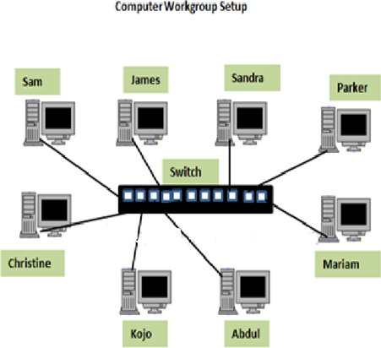

**PROCEDURE**

* **To set a static IP on your Windows computer**

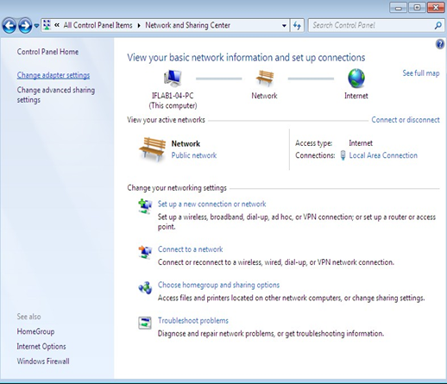 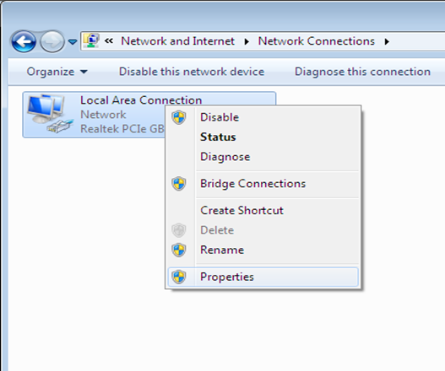

* 1. Click **StartMenu**>**Control Panel**>**Network and Sharing Center**.Click **Change adapter settings**.
  2. Right-click on **Local Area Connection** and clickon **Properties**.

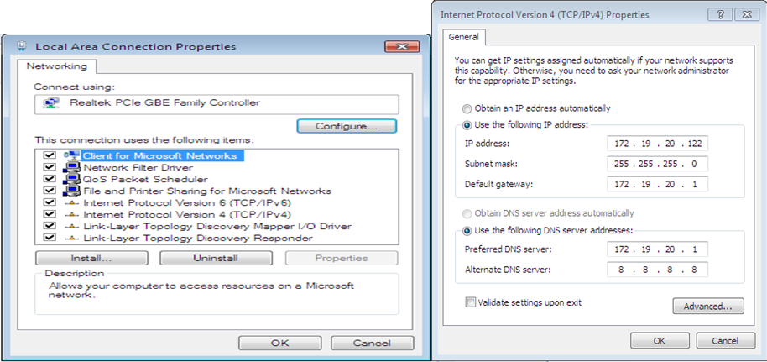

1. Select **Internet Protocol Version4(TCP/IPv4)**and click on **Properties**.

Select "**Use the following IP address"** and enter the IP address, Subnet Mask and DNS server.Click **OK** and close the **Local Area Connection** properties window.

* + - **How Workgroup works**

A computer joining a workgroup is assigned to the same workgroup name this process makes accessing the computers easier.

* + - **How to create a workgroup**

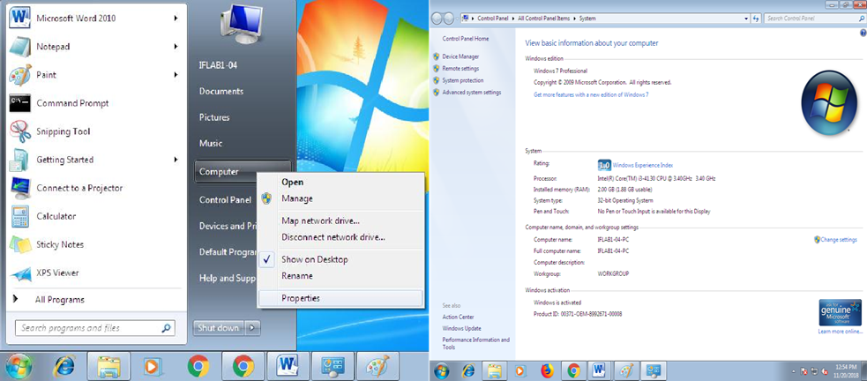

Clickon **Start** button Right-clickon **Computer** and then click **Properties**

**2.** Under **Computer name, domain, and workgroup settings**, click **Change settings**.

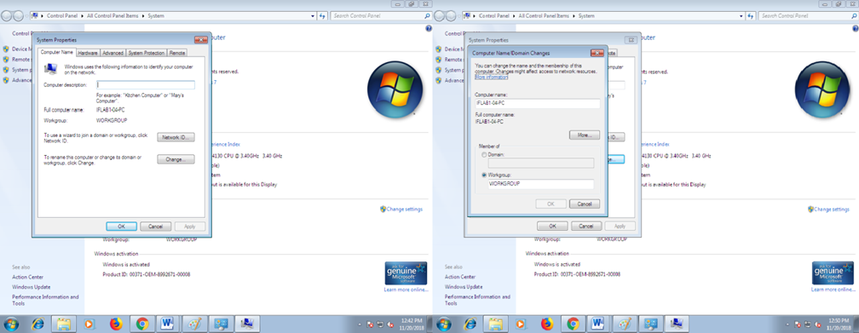

1. In the **SystemProperties** dialog box, click the **Computer Name** tab and then click **Change**.
2. In the Computer Name/Domain Changes dialog box, under Member of, click **Workgroup**
3. Then do one of the following: To join an **existing** workgroup, type the name of the workgroup thatyouwant to join, and thenclick **OK**. To create a **new** workgroup,type the name of the workgroup that you want to create,and then click **OK**

**Note:Repeat the steps of setup of IP address and setup of Workgroup for third computer**

* + - * **Peer-to-peer applications**.
        + **Skype**,an Internet telephony network,uses P2P technology.
        + **Instant messaging** systems and **online chat** networks.
        + **Bitcoin** and **PPCoin** are peer-to-peer-based digital currencies.
        + **Dalesa** a peer-to-peer web cache for LANs(based onIPmulticasting).
        + **OpenGarden**,connection sharing application that shares Internet access with other devices using Wi-Fi or

Bluetooth.

* + - * + Streamingmedia.**P2PTV**and**PDT**

1. **PRECAUTION**
   1. HandleComputerSystemandperipheralswithcare
   2. Follow SafetyPractices

**VIVA QUESTIONS**

1. What is peer?

2. Whatispeertopeernetwork?

3. Howpeertopeerisdiffersfromclient-servernetwork?

4. Giveadvantagesof peertopeer network.

5. Givedisadvantagesofpeertopeer network.

**RESULT:**

The experiment has been conducted successfully.

**EXPERIMENT / PRACTICAL -2**

# Share Files/Folder, Devices and Printer in the Network and access the shared resources from the other node

# AIM:

# Share Files/Folder, Devices and Printer in the Network and access the shared resources from the other node

**DESCRIPTION:**

Sharing files and folders between devices can be done in several ways, depending on your needs and the devices involved. Here are some common methods:

**1. Using Cloud Services**

* **Google Drive, Dropbox, OneDrive:** Upload files to these services and share links with others or sync files

across devices.

* **iCloud:** For Apple devices, iCloud allows file sharing and syncing.

**2. Network Sharing**

* **Windows:** Use the "Share" feature or set up a HomeGroup to share files and folders over a local network.
* **Mac:** Use AirDrop for quick sharing, or enable file sharing in system preferences.
* **Linux:** Use Samba to share files with Windows or other Linux systems on the same network.

**3. Direct Transfer**

* **USB Drive/External Hard Drive:** Physically transfer files using an external storage device.
* **Bluetooth:** Pair devices via Bluetooth and send files wirelessly.
* **Email:** Attach files to an email and send them to yourself or others.

**4. File Transfer Apps**

* **AirDroid:** For Android devices, allows file transfer to and from PCs.
* **SHAREit, Xender:** Cross-platform apps that facilitate file sharing between smartphones and computers.

**5. File Transfer Protocols**

* **FTP/SFTP:** Set up an FTP server on one device and connect to it from another.
* **WebDAV:** Use WebDAV to share files over the internet or a local network.

**6. Collaboration Tools**

* **Slack, Microsoft Teams, Google Workspace:** These tools often have integrated file sharing features for

team collaboration.

**7. Command Line Tools**

* **rsync, scp:** For advanced users, these command-line tools can be used for file transfer between devices.

**STEPS FOR SOME COMMON METHODS:**

**Google Drive:**

1. Upload the file to Google Drive.
2. Right-click the file and select "Share."
3. Enter the email address of the person you want to share with or get a shareable link.

**Windows Network Sharing:**

1. Right-click the folder you want to share and select "Properties."
2. Go to the "Sharing" tab and click "Share."
3. Choose the users to share with and set permissions.

**AirDrop (Mac/iOS):**

1. Open Finder (Mac) or Control Center (iOS) and enable AirDrop.
2. Select the file, click the "Share" button, and choose AirDrop.
3. Select the nearby device to send the file.

**HARD WARE REQUIREMENTS:**

1. Computer with Configuration – CPU HDD capacity: 250 GB RAM : 4 GB, i3 processor
2. Network Interface Card Manufacturer:Cisco
3. Switch (min. 8 ports)
4. Crossover Cable

**SOFTWARE REQUIREMENTS:**

Windows Operating Systems

**PracticalSignificance**

You can share Computer Resources

**MinimumTheoreticalBackground**

Are source,or system resource, is any physical or virtual component of limited availability within a computer system.Every device connected to a computer system is are source and every internal system component is also a resource.Major resource types are CPU time, Random access memory, Hard disk space, Network throughput, Electrical power, External Devices, Input/output operations. Virtual system resources include files, network connections and memory areas, where as a physical resource includes printer, scanner, fax machine etc.

**Types of System Resources**

* 1. Physical
  2. Virtual

**Types of Physical Resources Typesof Virtual Resources**

* + 1. Printer 1. Memory
    2. Scanner 2. Files
    3. FaxMachine 3. CPU time

**ResourceSharing**

A shared resource or network share is a device or piece of information on a computer that can be remotely accessed from another computer typically via a local area network or an enterprise Intranet, transparently as if it were a resource in the local machine.

Examples are shared file access(also known as disk sharing and folder sharing),shared printer access (printer sharing), shared scanner access, etc.

Resource sharing means reduction in hardware costs. Shared files mean reduction in memory requirement, which indirectly means reduction in file storage expenses.

A network share can become a security liability when access to the shared files is gained(often by devious means)by those who should not have access to them.Many computer worms have spread through resource sharing.

Printer sharing is a feature which allows you to access and use a printer from other computers in network.If there are ten employees in an organization, each having their own computer, they will require ten printers if they want to use there source at the same time.Printer sharing allows accessing the computers that can be interconnected using a network, and just one printer can efficiently provide the services to all ten users. Folder sharing is the public or private sharing of computer data or space in a network with various levels of access privilege.

A user sitting at one computer that is connected to network can easily see files present on another computers, provided he is authorized to do so.This saves him/her the hassle ofcarrying a storage device every time data needs to be transported from one system to another system

1. **DIAGRAMS/EXPERIMENTAL SETUP/WORKSITUATION**

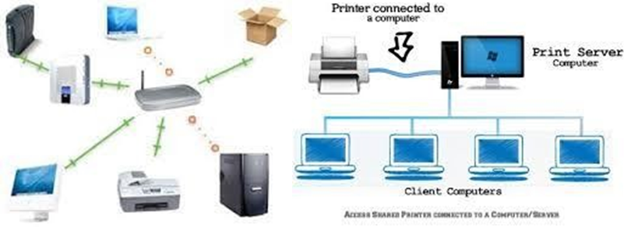

Fig.Resource sharing Fig.PrinterSharing

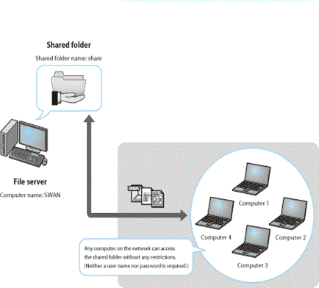

Folder Sharing

1. **PROCEDURE**

Share Printer and folder. Click on Start Button->Click on ControlPanel->Click on Network and Sharing Center->click on Change advanced sharing settings

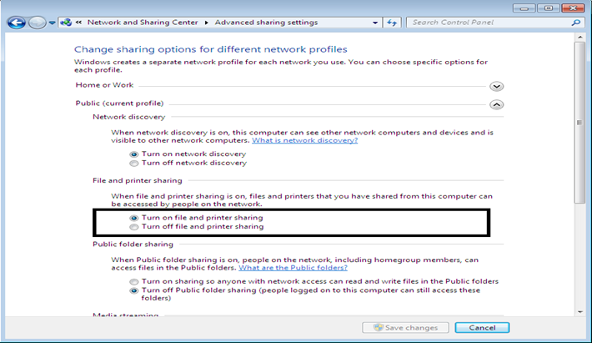

First start with the computer the printer is connected to.Make sure it‘s installed correctly with the latest drivers.

click Start >> Devices and Printers.

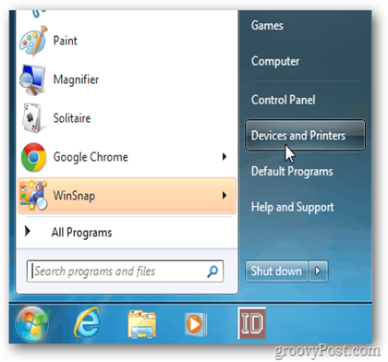

Next, right-click on the printer you want to share and select Printer Properties.

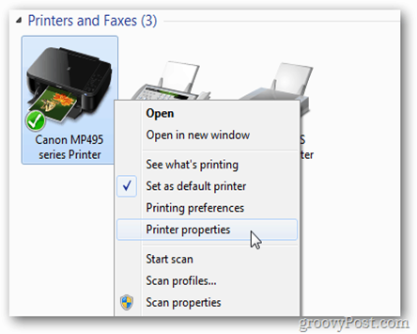

Click the Sharing tab.Make sure Share this Printer is checked and give it an easy to remember share name. Click OK.

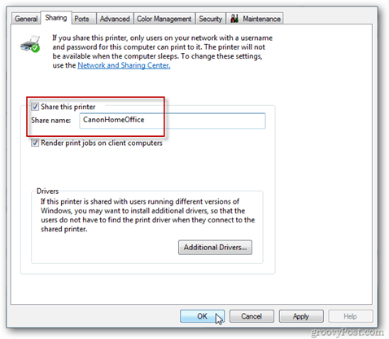

The computer the printer is attached to will need to be powered on to find and print to it. Now go to the other computer you want to print from.Click *Start>>Devices and Printers*

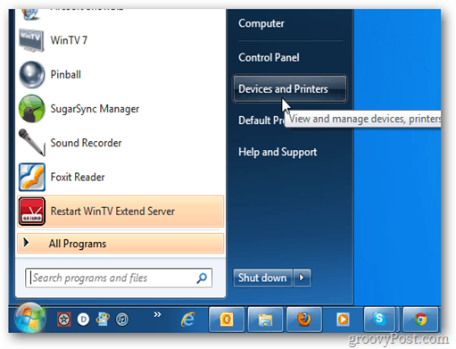

Click Add a Printer.

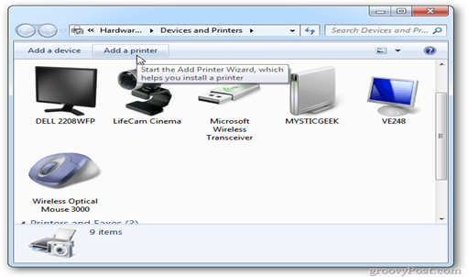

Next, click Add aNetwork,Wireless or Bluetooth Printer.

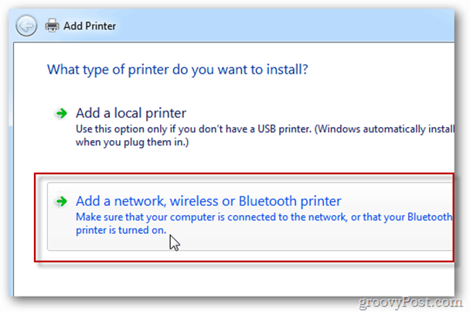

The system will search you rnet work for the shared printer.When it finds the printer, highlight it and click Next.

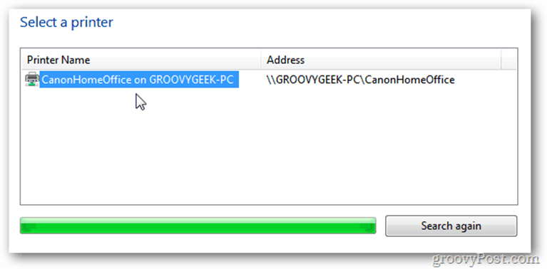

Success.Click Next.

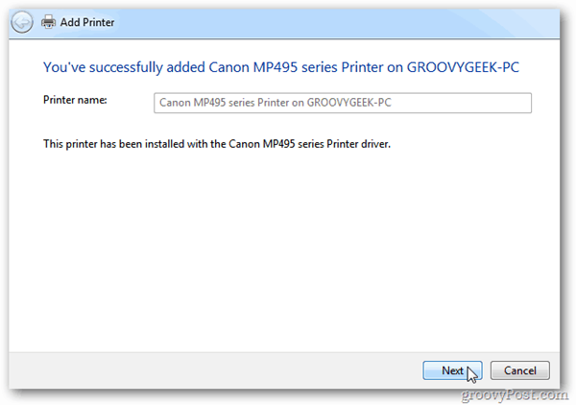

Back in Devices and Printers,you‘ll find the printer listed.Send a test page to the printer to verify it‘s working.

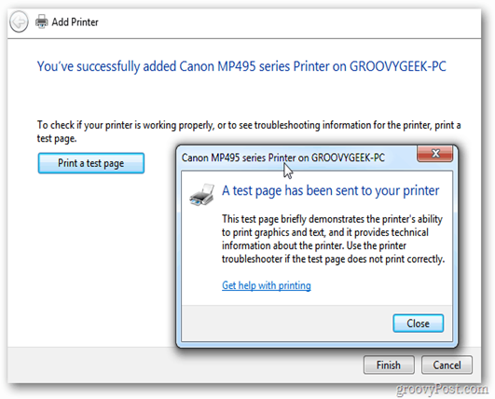

If Windows doesn‘t automatically find the printer, click ThePrinter That I Want Isn‘t Listed.

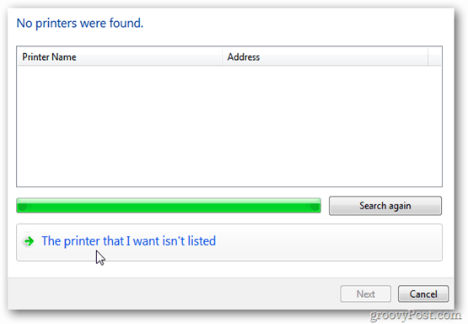

Check Select a Shared Printer byname and type the path in directly.

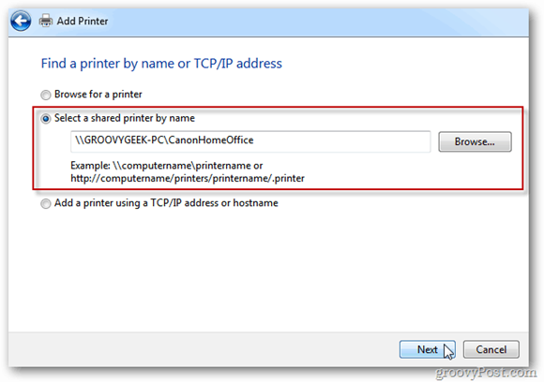

Or click Browse to find the printer and select it.

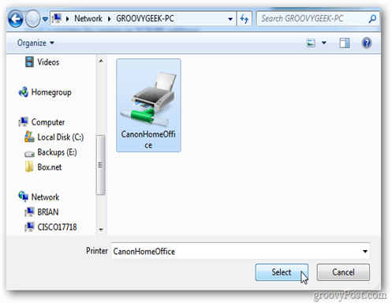

**SharingSpecificFolders**

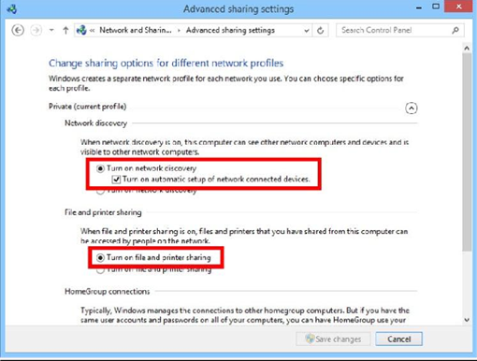

**Ensure that File and Printer Sharing is enabled.** In order to share specific folders, you will need to have this feature enabled. The method for enabling it varies slightly depending on which version of Windows you are using. It is highly recommended that you do not enable folder sharing when on a public network such as a school or coffee shop.

**Windows 7** - Click the Start button, type "control panel", and press ↵ Enter. Double-click the "Network and Sharing Center"icon. Click the"Change advanced sharing settings"link. Expand the profile that you want to enable sharing on (Home/Work or Public). Turn on both "Network discovery" and "File and printer sharing". Click the "Save changes" button and enter your administrator password if necessary.

**Find the folder you wish to share.** Once File and Printer Sharing has been enabled, you can share any folder on your hard drive with other people on your network. Navigate to the folder that you want to share using Explorer. Right-click on it.

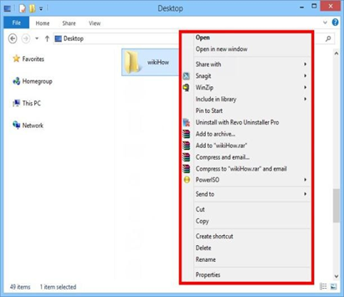

1. **Selectthe"Sharewith"option.** This will open the Sharing sub menu.You can choose to share it with [everyone in your Homegroup](https://www.wikihow.com/Set-up-a-Network-Homegroup) or select specific people to share it with.When choosing a Homegroup option,you can allow other Homegroup members to both read and write to the folder, or limit them to just read from it.

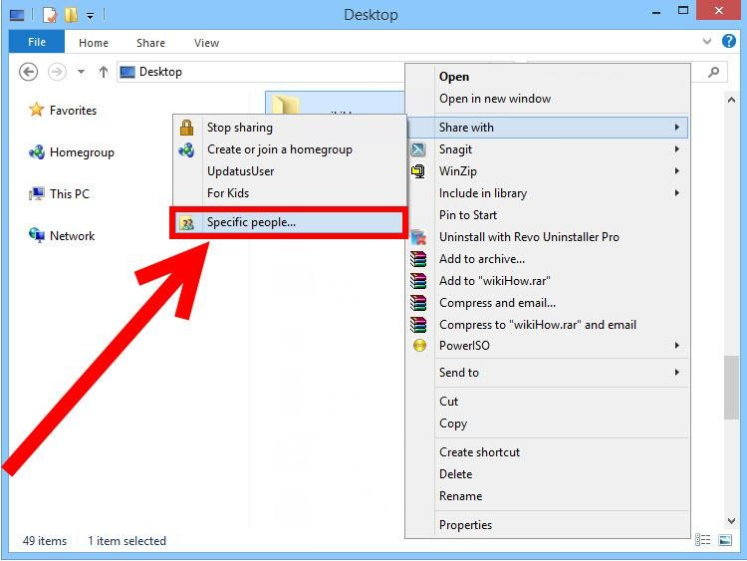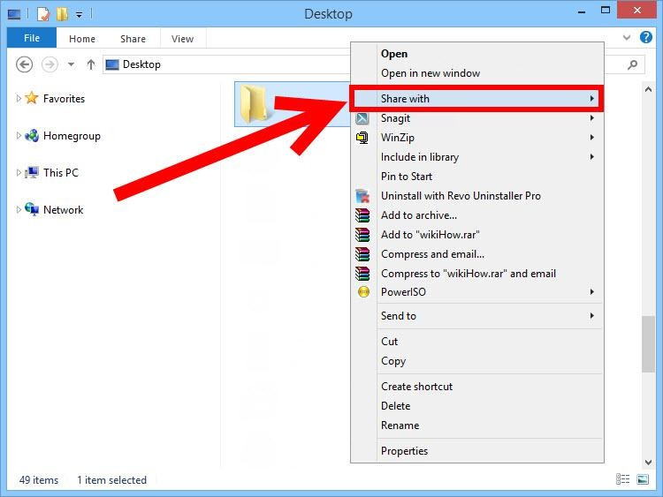

**Click the"Specificpeople"option to select which users you want to sharewith.**This will open a new window with a list of all the users that currently have access to the folder. You can add users to this list and give them specific permissions for the folder.

* + To share the folder with everyone, click the dropdown menu at the top and select "Everyone". Click the Add button.
  + To share with specific users,click the dropdown menu and select the mortype in the name and click Add.

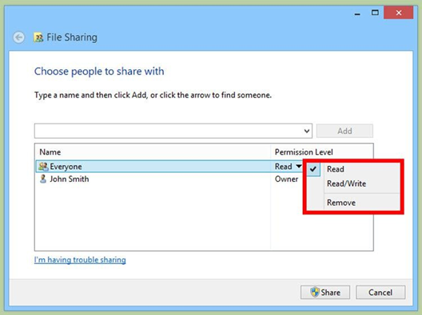

**Set permissions for users on the list.** Find a user on the list that you want to change the permissions for. Look in the Permissions Level column, and click the arrow next to the existing permission. Select the new one from the list.

* + Read-Usercansee,copy,and open files from the folder,but cannot change files or add new ones.
  + Read/Write-Besides Readabilities,users can change files and addnew files to the shared folder. Files can be

deleted by users with Read/Write permissions.

* + Remove-Removes permissions for this user, and removes them from the list.

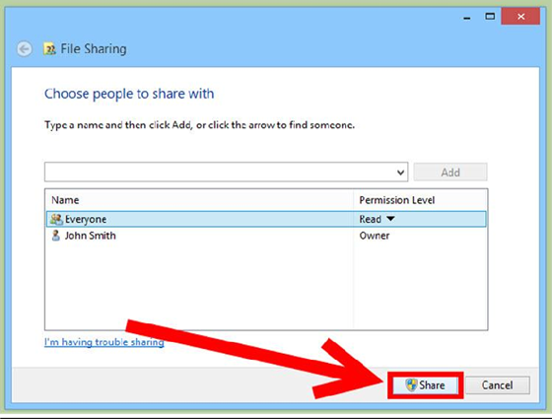

**VIVAQUESTIONS**

* 1. Define system resource. List resources that can be shared in network?
  2. Give the examples of physical and virtual resource.Define resource sharing and state its needs.
  3. Give advantages and disadvantages of printer sharing and folder sharing.
  4. How security is measure issue in resource sharing?
  5. Which are different privileges associated w ith folder?

**RESULT:**

The experiment has been conducted successfully.

**EXPERIMENT / PRACTICAL -3**

Use Wireshark Packet sniffer software and capture TCP, UDP, IP, ARP, ICMP, Telnet, FTP packets with sample output

**AIM:**

Use Wireshark Packet sniffer software and captures TCP,UDP, IP, ARP, ICMP, Telnet, FTP packets with sample output

**DESCRIPTION:**

Wireshark is a powerful network protocol analyzer that can capture and display data packets traveling through a network. It supports various protocols and can be used to troubleshoot network issues, analyze network performance, and ensure security. Here’s an overview of how Wireshark handles different types of packets:

1. **TCP (Transmission Control Protocol)**: Wireshark can capture TCP packets, which are used for reliable, ordered, and error-checked delivery of data between applications. TCP is commonly used for protocols such as HTTP, HTTPS, FTP, and Telnet.
2. **UDP (User Datagram Protocol)**: Wireshark captures UDP packets, which provide a connectionless communication model with a minimal protocol mechanism. UDP is used for time-sensitive transmissions such as DNS queries and streaming media.
3. **IP (Internet Protocol)**: Wireshark captures IP packets, which are used to deliver data across network boundaries. Both IPv4 and IPv6 packets can be analyzed.
4. **ARP (Address Resolution Protocol)**: Wireshark can capture ARP packets, which are used for mapping network addresses (IP) to physical addresses (MAC).
5. **ICMP (Internet Control Message Protocol)**: Wireshark captures ICMP packets, which are used for diagnostic and error-reporting purposes in network operations (e.g., ping).
6. **Telnet**: Wireshark can capture Telnet packets, which provide bidirectional interactive text-oriented communication using a virtual terminal connection over TCP.
7. **FTP (File Transfer Protocol)**: Wireshark captures FTP packets, which are used for the transfer of files between a client and server on a network.

With Wireshark, users can inspect individual packets, follow protocol streams, and apply various filters to narrow down the data for more precise analysis. This makes it an invaluable tool for network administrators, cybersecurity professionals, and developers.

**PROCEDURE:**

Wireshark is a powerful tool used for network packet analysis. It allows you to capture and interactively browse the traffic running on a computer network. Below are the steps to capture various types of packets (TCP, UDP, IP, ARP, ICMP, Telnet, FTP) using Wireshark, along with sample outputs.

**Steps to Capture Packets Using Wireshark**

1. **Install Wireshark**:
   * Download and install Wireshark from the [official website](https://www.wireshark.org/).
2. **Start Wireshark**:
   * Open Wireshark on your machine.
   * Select the network interface you want to capture traffic on (e.g., Ethernet, Wi-Fi).
3. **Begin Capture**:
   * Click on the interface to start capturing packets.
   * You can stop the capture by clicking on the red square button.
4. **Apply Display Filters**:
   * Use Wireshark's display filters to focus on specific types of traffic.

**CAPTURING SPECIFIC PACKET TYPES**

**1. TCP Packets**

* **Filter:** tcp
* **Sample Output:**

plaintext

Copy code

No. Time Source Destination Protocol Length Info

1 0.000000 192.168.1.2 192.168.1.1 TCP 66 55914 → 80 [SYN] Seq=0 Win=64240 Len=0 MSS=1460 SACK_PERM=1 TSval=12345678 TSecr=0 WS=128

**2. UDP Packets**

* **Filter:** udp
* **Sample Output**:

plaintext

Copy code

No. Time Source Destination Protocol Length Info

2 0.001234 192.168.1.2 192.168.1.3 UDP 58 50624 → 53 Len=16

**3. IP Packets**

* **Filter:** ip
* **Sample Output:**

plaintext

Copy code

No. Time Source Destination Protocol Length Info

3 0.002345 192.168.1.2 192.168.1.4 IP 98 192.168.1.2 → 192.168.1.4 [SYN] Seq=0 Win=64240 Len=0

**4. ARP Packets**

* **Filter:** arp
* **Sample Output:**

plaintext

Copy code

No. Time Source Destination Protocol Length Info

4 0.003456 192.168.1.1 192.168.1.2 ARP 42 Who has 192.168.1.2? Tell 192.168.1.1

**5. ICMP Packets**

* **Filter: i**cmp
* **Sample Output:**

plaintext

Copy code

No. Time Source Destination Protocol Length Info

5 0.004567 192.168.1.2 192.168.1.1 ICMP 74 Echo (ping) request id=0x1234, seq=1/256, ttl=64

**6. Telnet Packets**

* **Filter:** telnet
* **Sample Output:**

plaintext

Copy code

No. Time Source Destination Protocol Length Info

6 0.005678 192.168.1.2 192.168.1.5 TELNET 74 Telnet Data

**7. FTP Packets**

* **Filter:** ftp
* **Sample Output:**

plaintext

Copy code

No. Time Source Destination Protocol Length Info

7 0.006789 192.168.1.2 192.168.1.6 FTP 78 Request: USER anonymous

**Additional Tips**

* **Filtering**: You can combine filters using logical operators, e.g., tcp || udp to show both TCP and UDP packets.
* **Analysis**: Use the "Statistics" menu for in-depth analysis and graphical representations of the traffic.

**RESULT:**

The experiment has been conducted successfully.

**EXPERIMENT / PRACTICAL -4**

Implement Write and analyze the output of various Network commands such as ping, ipconfig, arp, netstat, tracert, nslookup, hostname, systeminfo etc., with sample outputs

**AIM:**

Implement Write and analyze the output of various Network commands such as ping, ipconfig, arp, netstat, tracert, nslookup, hostname, systeminfo etc., with sample outputs

**DESCRIPTION:**

Network commands are instructions used to configure, manage, and troubleshoot network devices and connections. These commands can be issued through command-line interfaces (CLI) on network devices such as routers, switches, firewalls, and computers. Here’s a detailed description of some commonly used network commands:

**Basic Network Commands**

1. **ping**:
   * **Purpose**: Tests connectivity between two devices on a network.
   * **Usage**: ping [hostname/IP address]
   * **Example**: ping 192.168.1.1
2. **traceroute/tracert**:
   * **Purpose**: Traces the path packets take from one device to another.
   * **Usage**:
     + Unix/Linux: traceroute [hostname/IP address]
     + Windows: tracert [hostname/IP address]
   * **Example**: traceroute google.com or tracert google.com
3. **ipconfig/ifconfig**:
   * **Purpose**: Displays network configuration details.
   * **Usage**:
     + Windows: ipconfig
     + Unix/Linux: ifconfig
   * **Example**: ipconfig /all or ifconfig eth0
4. **netstat**:
   * **Purpose**: Displays network connections, routing tables, interface statistics, masquerade connections, and multicast memberships.
   * **Usage**: netstat [options]
   * **Example**: netstat -a
5. **nslookup**:
   * **Purpose**: Queries the Domain Name System (DNS) to obtain domain name or IP address mapping.
   * **Usage**: nslookup [hostname/IP address]
   * **Example**: nslookup example.com
6. **hostname**:
   * **Purpose**: Displays or sets the system's hostname.
   * **Usage**: hostname [new-hostname]
   * **Example**: hostname

**Network Configuration Commands**

1. **route**:
   * **Purpose**: Displays or modifies the IP routing table.
   * **Usage**: route [add/delete] [destination] [gateway]
   * **Example**: route add 192.168.1.0 mask 255.255.255.0 192.168.1.1
2. **arp**:
   * **Purpose**: Displays and modifies the ARP (Address Resolution Protocol) cache.
   * **Usage**: arp [options] [hostname/IP address]
   * **Example**: arp -a
3. **iptables**:
   * **Purpose**: Configures the IP packet filter rules of the Linux kernel firewall.
   * **Usage**: iptables [options]
   * **Example**: iptables -L
4. **ifup/ifdown**:
   * **Purpose**: Activates or deactivates network interfaces on Unix/Linux systems.
   * **Usage**: ifup [interface] or ifdown [interface]
   * **Example**: ifup eth0 or ifdown eth0

**Advanced Network Commands**

1. **tcpdump**:
   * **Purpose**: Captures and displays packets on a network.
   * **Usage**: tcpdump [options]
   * **Example**: tcpdump -i eth0
2. **nmap**:
   * **Purpose**: Scans networks to discover hosts and services.
   * **Usage**: nmap [options] [hostname/IP address]
   * **Example**: nmap -sP 192.168.1.0/24
3. **wireshark**:
   * **Purpose**: Network protocol analyzer for capturing and analyzing traffic.
   * **Usage**: Typically used with a graphical interface, but can be run with command-line options.
   * **Example**: wireshark (GUI) or tshark -i eth0 (CLI)

**Windows-Specific Commands**

1. **netsh**:
   * **Purpose**: Configures and displays the status of network components.
   * **Usage**: netsh [context] [command]
   * **Example**: netsh interface ip show config
2. **Get-NetIPAddress**:
   * **Purpose**: Displays IP address configuration on Windows PowerShell.
   * **Usage**: Get-NetIPAddress
   * **Example**: Get-NetIPAddress

**Unix/Linux-Specific Commands**

1. **dig**:
   * **Purpose**: Queries DNS name servers for information.
   * **Usage**: dig [hostname/IP address]
   * **Example**: dig example.com
2. **ip**:
   * **Purpose**: Manages IP addresses, network devices, and routing tables.
   * **Usage**: ip [command]
   * **Example**: ipaddr show

These commands are fundamental tools for network administrators and IT professionals, enabling them to manage and troubleshoot network infrastructure efficiently.

**PROCEDURE:**

**1. ping**

**Description:** The ping command is used to check the network connectivity between the host computer and a target (usually another computer or a server).

**Command:**

bash

Copy code

ping google.com

**Sample Output:**

plaintext

Copy code

Pinging google.com [142.250.64.78] with 32 bytes of data:

Reply from 142.250.64.78: bytes=32 time=14ms TTL=54

Reply from 142.250.64.78: bytes=32 time=13ms TTL=54

Reply from 142.250.64.78: bytes=32 time=15ms TTL=54

Reply from 142.250.64.78: bytes=32 time=12ms TTL=54

Ping statistics for 142.250.64.78:

Packets: Sent = 4, Received = 4, Lost = 0 (0% loss),

Approximate round trip times in milli-seconds:

Minimum = 12ms, Maximum = 15ms, Average = 13ms

**Analysis:**

* The target (google.com) resolves to the IP address 142.250.64.78.
* All packets sent were received (0% packet loss).
* The round-trip time (latency) varies between 12ms and 15ms, indicating a stable and responsive connection.

**2. ipconfig**

**Description:** The ipconfig command displays the network configuration details of the local machine.

**Command:**

bash

Copy code

ipconfig

**Sample Output:**

plaintext

Copy code

Windows IP Configuration

Ethernet adapter Ethernet:

Connection-specific DNS Suffix . : example.local

Link-local IPv6 Address . . . . . : fe80::1c9e:5fbc:b001:6833%12

IPv4 Address. . . . . . . . . . . : 192.168.1.10

Subnet Mask . . . . . . . . . . . : 255.255.255.0

Default Gateway . . . . . . . . . : 192.168.1.1

**Analysis:**

* The computer has both an IPv4 address (192.168.1.10) and a link-local IPv6 address.
* The subnet mask is 255.255.255.0, indicating a standard class C network.
* The default gateway is 192.168.1.1, typically the router's address.

**3. arp**

**Description:** The arp command is used to view and manipulate the ARP (Address Resolution Protocol) cache, which maps IP addresses to MAC addresses.

**Command:**

bash

Copy code

arp -a

**Sample Output:**

plaintext

Copy code

Interface: 192.168.1.10 --- 0x12

Internet Address Physical Address Type

192.168.1.1 00-14-22-01-23-45 dynamic

192.168.1.15 00-25-96-FF-EE-77 dynamic

**Analysis:**

* The ARP cache shows that the IP address 192.168.1.1 maps to the MAC address 00-14-22-01-23-45.
* Another device on the network with IP 192.168.1.15 maps to the MAC address 00-25-96-FF-EE-77.

**4. netstat**

**Description:** The netstat command displays network statistics, including current connections, routing tables, and interface statistics.

**Command:**

bash

Copy code

netstat

**Sample Output:**

plaintext

Copy code

Active Connections

Proto Local Address Foreign Address State

TCP 192.168.1.10:55478 ec2-52-87-185-95:443 ESTABLISHED

TCP 192.168.1.10:55479 216.58.206.14:443 TIME_WAIT

TCP 192.168.1.10:55480 172.217.10.46:443 ESTABLISHED

**Analysis:**

* The computer has active TCP connections to various remote addresses.
* The state ESTABLISHED indicates ongoing communication, while TIME_WAIT shows the connection is closing.

**5. tracert**

**Description:** The tracert command traces the path packets take to reach a network host.

**Command:**

bash

Copy code

tracert google.com

**Sample Output:**

plaintext

Copy code

Tracing route to google.com [142.250.64.78] over a maximum of 30 hops:

1 1 ms<1 ms<1 ms 192.168.1.1

2 12 ms 11 ms 12 ms 10.0.0.1

3 13 ms 12 ms 11 ms 172.16.0.1

4 14 ms 13 ms 12 ms 172.217.10.46

5 15 ms 14 ms 13 ms google.com [142.250.64.78]

**Analysis:**

* The command shows the route and time taken to reach each hop.
* The final destination (google.com) is reached in 5 hops.

**6. nslookup**

**Description:** The nslookup command queries DNS servers to obtain domain name or IP address mapping.

**Command:**

bash

Copy code

nslookup google.com

**Sample Output:**

plaintext

Copy code

Server: resolver1.opendns.com

Address: 208.67.222.222

Non-authoritative answer:

Name: google.com

Addresses: 142.250.64.78

**Analysis:**

* The DNS server used for the query is 208.67.222.222.
* The resolved IP address for google.com is 142.250.64.78.

**7. hostname**

**Description:** The hostname command displays the name of the current host (computer).

**Command:**

bash

Copy code

hostname

**Sample Output:**

plaintext

Copy code

MyComputer

**Analysis:**

* The name of the host machine is MyComputer.

**8. systeminfo**

**Description:** The systeminfo command provides detailed information about the computer's system configuration.

**Command:**

bash

Copy code

systeminfo

**SAMPLE OUTPUT:**

plaintext

Copy code

Host Name: MyComputer

OS Name: Microsoft Windows 10 Pro

OS Version: 10.0.19041 N/A Build 19041

OS Manufacturer: Microsoft Corporation

System Manufacturer: Dell Inc.

System Model: XPS 15 9570

System Type: x64-based PC

Processor(s): 1 Processor(s) Installed.

[01]: Intel64 Family 6 Model 158 Stepping 10 GenuineIntel ~2200 Mhz

BIOS Version: Dell Inc. 1.12.0, 1/22/2021

**ANALYSIS:**

* The computer's hostname is MyComputer.
* It is running Windows 10 Pro, version 19041.
* The system is a Dell XPS 15 9570 with an Intel processor.

These commands provide a comprehensive view of network and system information, useful for diagnostics and troubleshooting.

**RESULT:**

The experiment has been conducted successfully.

**EXPERIMENT / PRACTICAL -5**

Installation set up of Network simulator software (NS2 / NS3 / NetSim / OPNET /QualNet/OMNet++/J-Sim and Cisco Packet Tracer). Installation Procedure for Ns2 on Windows10/11

**AIM:**

Installation set up of Network simulator software (NS2/NS3/NetSim/OPNET/QualNet/OMNet++/J-Sim and Cisco Packet Tracer). Installation Procedure for Ns2onWindows10/11

**DESCRIPTION:**

NS2, or Network Simulator 2, is a discrete event simulator targeted at networking research. It provides substantial support for simulation of TCP, routing, and multicast protocols over wired and wireless networks. Here are some key features and aspects of NS2:

1. **Discrete Event Simulation**: NS2 uses discrete event simulation techniques to model the operation of networks. Events are processed in a sequential manner, which helps in studying the behavior of the network under different conditions.
2. **Support for Various Protocols**: It supports a wide range of network protocols, including TCP, UDP, and routing algorithms. This allows researchers to simulate complex network behaviors and evaluate the performance of different protocols.
3. **Wired and Wireless Network Simulations**: NS2 can simulate both wired and wireless network scenarios. It includes models for various types of networks, such as LANs, WANs, ad-hoc networks, and sensor networks.
4. **Extensibility**: The simulator is highly extensible, allowing users to create and integrate new modules and protocols. This flexibility makes NS2 a valuable tool for researchers who need to test novel networking ideas.
5. **Visualization Tools**: NS2 comes with tools like NAM (Network Animator) for visualizing the simulation. These tools help users understand the behavior of the network and debug their simulations.
6. **Scripting Language**: NS2 simulations are typically defined using the OTcl scripting language, which is an object-oriented extension of Tcl. This allows for easy and flexible setup of simulation scenarios.
7. **Wide Usage and Community Support**: NS2 is widely used in the academic and research community. A large number of research papers and studies have been based on simulations conducted with NS2, and it has a strong user base that contributes to its ongoing development and support.
8. **Open Source**: NS2 is an open-source project, which means its source code is available for users to modify and extend according to their needs.

Overall, NS2 is a powerful and versatile tool for network simulation, making it a popular choice for researchers and students in the field of computer networking.

**PROCEDURE**

**STEP 1:**

Turnon Developer Mode Open search(Windows+S)and type“Power Shell Developer Settings”and click on Open as shown below

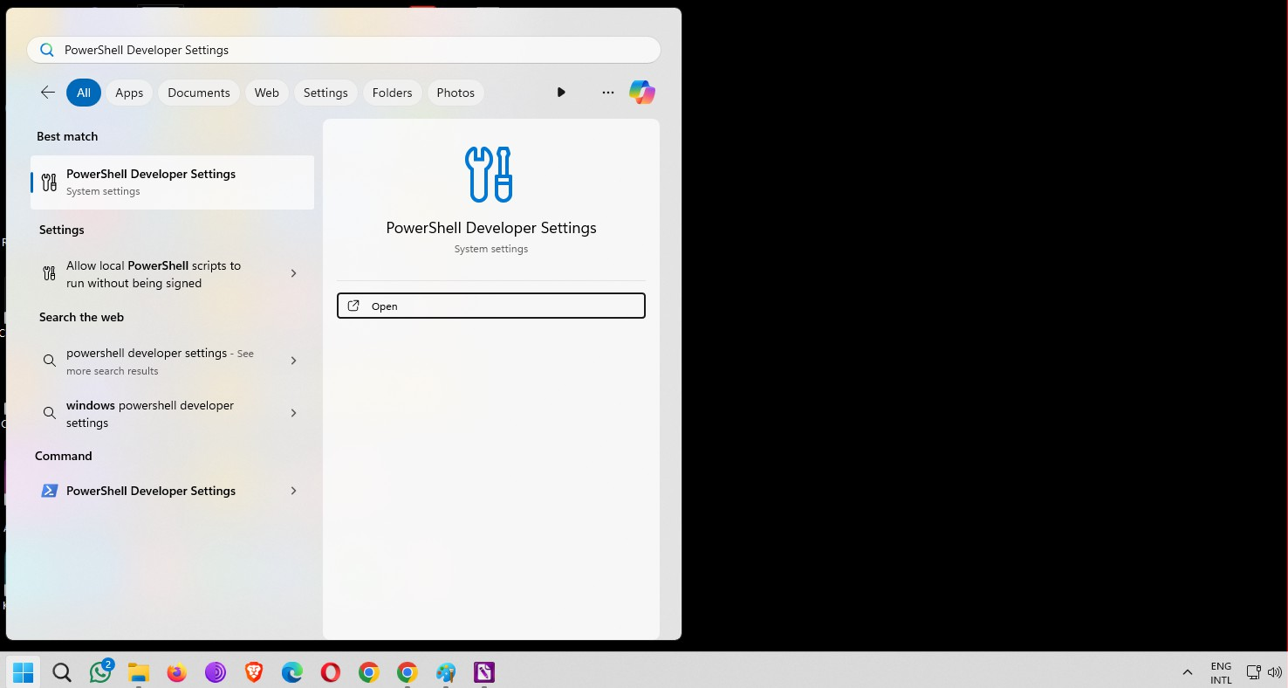

Turnon the option“Install apps from any source, including loose files”as shown below, click YES and close the window.

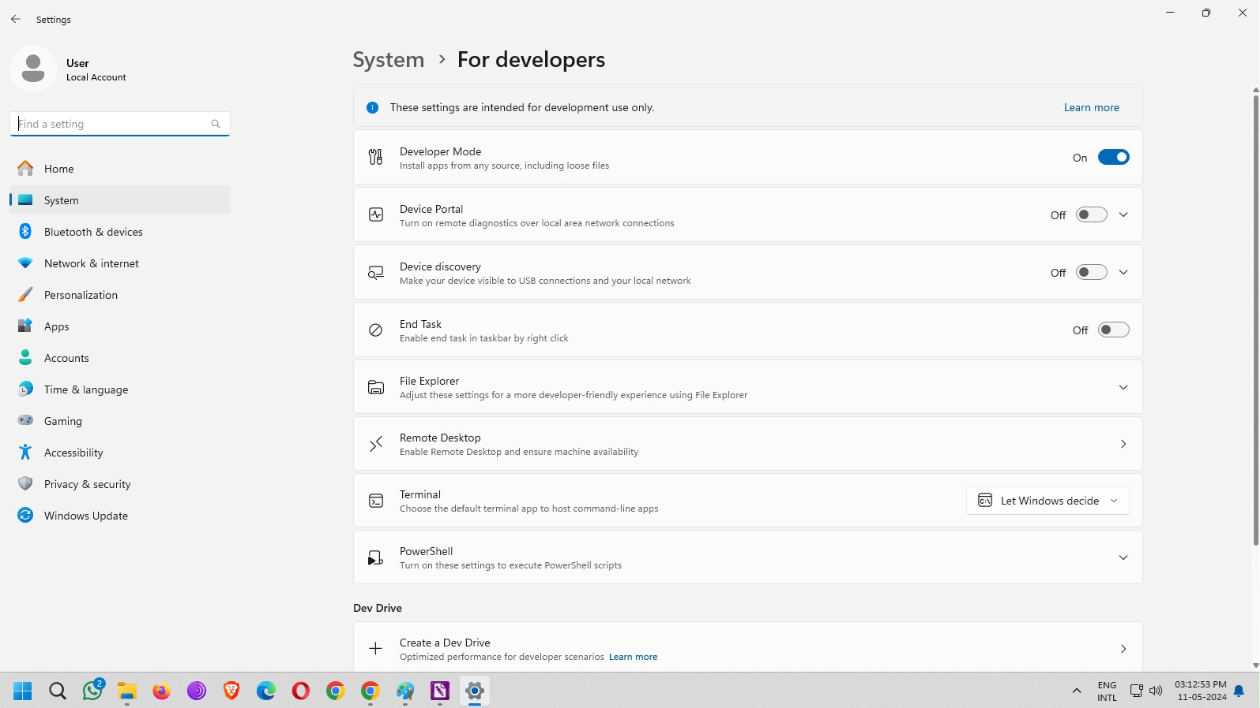

**STEP2**

TurnonWSL(WindowsSubsystemforLinux)andVirtualMachinePlatform

Open search and type“turn windows features on or off”and clickon Open as shown below:

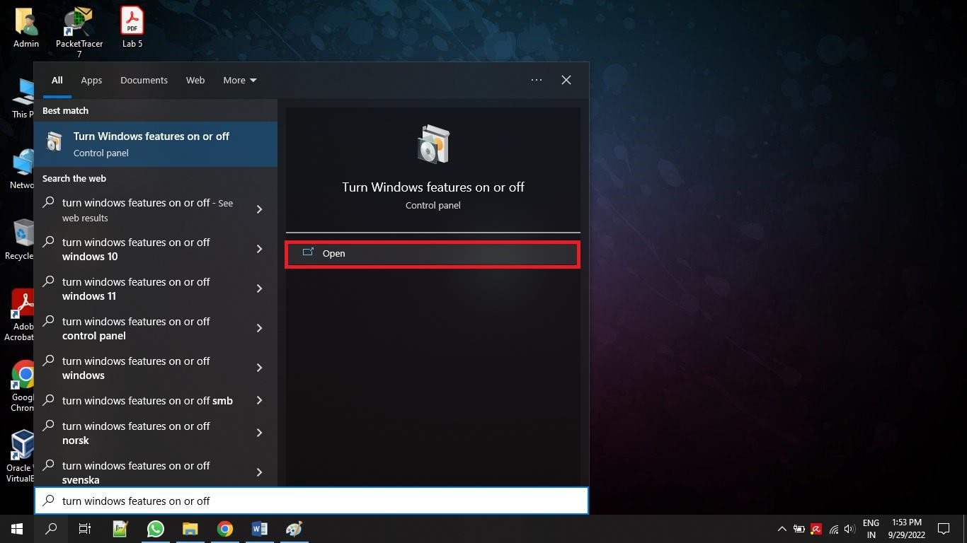

Scroll down the options and check the items named “Windows Subsystem for Linux” and “Virtual Machine Platform” and click on OK.

Restart the System.

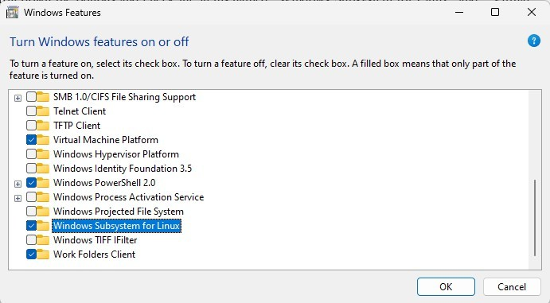

**STEP3**

Open search and type“Windows Power Shell”,and run as administrator

Type the following commands inWindows Power Shell

wsl--install wsl--update

**STEP4**

Install Ubuntu from Microsoft Store.

Click on search and type“Microsoft Store”and clickon Open.

In the search bar at the top,type“Ubuntu24.04LTS”and clickon“Get”button as shown below:

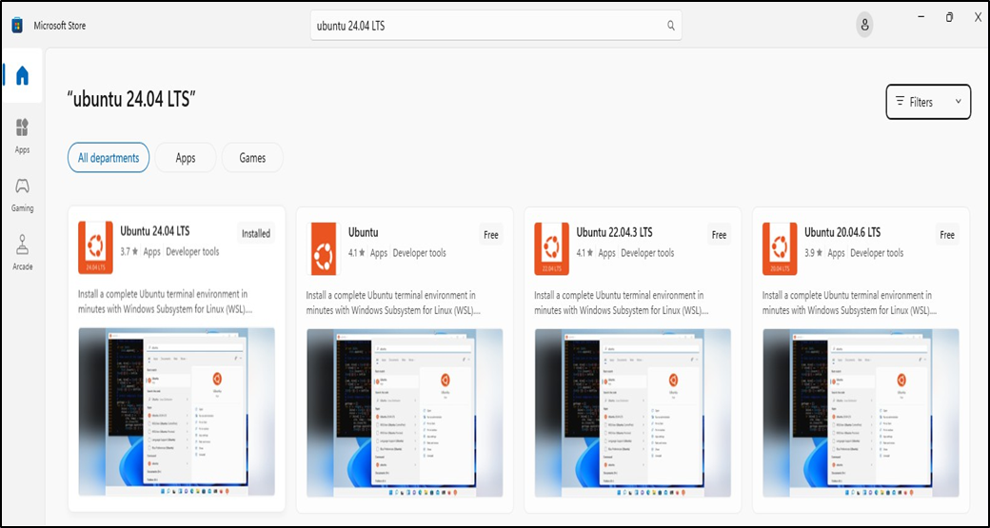

It will take sometime to download and install the Ubuntu app as it is nearly400 MB.

**STEP5**

Open search and type“Ubuntu”and clickon”Runas administrator”.

As it is the first time you are opening Ubuntu, it will ask for User name and Password. Give a username and password of your choice and hit enter key.

Now you should see a prompt as shown below:

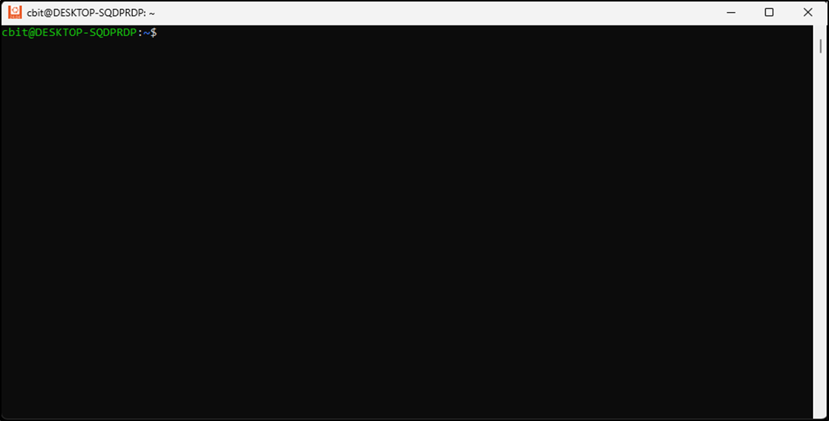

Type the following commands one by one and hit enter after each command:

1. sudoapt update
2. sudoaptupgrade
3. sudoapt-getinstall ns2
4. sudoaptinstalltcl

Download nam_1.14_amd64.debornam_1.15-10-ubuntu14_amd64.debfilesfromtheinternet. Please download nam_1.14_amd64.deb from the below website https://drive.google.com/file/d/0B7S255p3kFXNNmtLeXhsaG5hXzQ/edit?resourcekey=0- NJmLwKSqlXCAjXSHr6ILiA

Pleasedownload nam_1.15-10-ubuntu14_amd64.debfromthebelowwebsite

https://drive.google.com/file/d/0B7S255p3kFXNdmxzSmRzaVRWb28/view?usp=sharing

Open terminal and navigate to the folder where nam_1.14_amd 64.debornam_1.15-10-ubuntu14_amd64.deb file is downloaded and run the following command.

$sudodpkg--installnam_1.14_amd64.deb

$sudodpkg--installnam_1.15-10-ubuntu14_amd64.deb (Recommendedtoinstallnam1.15)

**STEP 6**

Changing the location to working directory.

For this example, for working directory name is“NS2”and it is located on my“Desktop”.

The complete path to “NS2” directory on my PC is “C:\Users\User\Desktop\NS2Programs”. To change the location to the above directory,type the following command and hit Enter key.

cd/mnt/c/Users/User/Desktop/’NS2Programs’

**STEP 7**

Running the program using“ns” command.

ns Program0-label.tcl

Now, you should be able to see the network animator (nam) window with the topology as shown in the below figure.

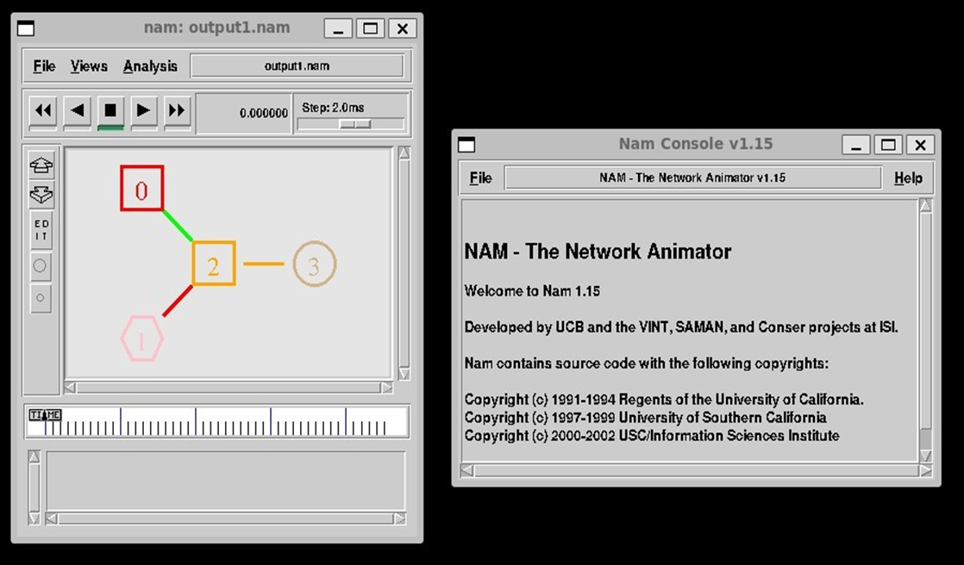

**RESULT:**

The experiment has been conducted successfully.

**EXPERIMENT / PRACTICAL -6**

Write a TCL script to simulate Star topology

**AIM:**

Write a TCL script to simulate Star topology

### DESCRIPTION:

Star networks are one of the most common computer network topologies. In its simplest form, a star networkconsists of one central switch, hub or computer, which acts as a conduit to transmit messages. This consists of a central node, to which all other nodes are connected; this central node provides a common connection point for all nodes through a hub.In star topology, every node(computer workstation or anyother peripheral)is connected to a central node called a hub or switch. The switch is the server and the peripherals are the clients. Thus, the hub and leaf nodes, and the transmission lines between them, form a graph with the topology of a star. If the central node is passive, the originating node must be able to tolerate the reception of an echo of its own transmission, delayed by the two-way transmission time (i.e. to and from the central node) plus any delay generated in the central node. An active star network has an active central node that usually has the means to prevent echo-related problems.

The star topology reduces the damage caused by line failure by connecting all of the systems to a central node.When applied to a bus-based network, this central hub rebroadcasts all transmissions received from any peripheral node to all peripheral nodes on the network, sometimes including the originating node. All peripheral nodes may thus communicate with all others by transmitting to, and receiving from, the central node only. The failure of a transmission line linking any peripheral node to the central node will result in the isolation of that peripheral node from all others,but the rest of the systems will be unaffected.

**HARD WARE REQUIREMENTS:**

1. Computer with Configuration – CPU HDD capacity: 250 GB RAM: 4 GB, i3 processor

**SOFTWARE REQUIREMENTS:**

Windows 11 Operating Systems,Ubuntu 20.04 Linux, NS 2.35 Simulator

**ALGORITHM:**

1. Create a simulator object
2. Define different colors for different dataflows
3. Open a nam trace file and define finish procedure then close the trace file, and execute nam on tracefile.
4. Create six nodes that forms a network numbered from 0 to 5
5. Create duplex links between the nodes to form a Star Topology
6. Setup TCP Connection between 1 and n3
7. Apply CBR Traffic over TCP
8. Schedule events and run the program.

**SOURCE CODE:**

#This program will create a Star Topolgy using for loop in tcl in order to use less statements

set ns [new Simulator]

$ns color 1 blue

$ns color 2 red

$ns rtproto DV

setnf [open out.nam w]

$ns namtrace-all $nf

proc finish {} {

global ns nf

$ns flush-trace

close $nf

execnamout.nam

exit 0

}

#creating Nodes

for {set i 0} {$i<7} {incri} {

set n($i) [$ns node]

}

#Creating Links

for {set i 1} {$i<7} {incri} {

$ns duplex-link $n(0) $n($i) 512Kb 10ms SFQ

}

#Orienting The nodes

$ns duplex-link-op $n(0) $n(1) orient left-up

$ns duplex-link-op $n(0) $n(2) orient right-up

$ns duplex-link-op $n(0) $n(3) orient right

$ns duplex-link-op $n(0) $n(4) orient right-down

$ns duplex-link-op $n(0) $n(5) orient left-down

$ns duplex-link-op $n(0) $n(6) orient left

#TCP_Config

set tcp0 [new Agent/TCP]

$tcp0 set class_ 1

$ns attach-agent $n(1) $tcp0

set sink0 [new Agent/TCPSink]

$ns attach-agent $n(4) $sink0

$ns connect $tcp0 $sink0

#UDP_Config

set udp0 [new Agent/UDP]

$udp0 set class_ 2

$ns attach-agent $n(2) $udp0

set null0 [new Agent/Null]

$ns attach-agent $n(5) $null0

$ns connect $udp0 $null0

#CBR Config

set cbr0 [new Application/Traffic/CBR]

$cbr0 set rate_ 256Kb

$cbr0 attach-agent $udp0

#FTP Config

set ftp0 [new Application/FTP]

$ftp0 attach-agent $tcp0

#Scheduling Events

$ns rtmodel-at 0.5 down $n(0) $n(5)

$ns rtmodel-at 0.9 up $n(0) $n(5)

$ns rtmodel-at 0.7 down $n(0) $n(4)

$ns rtmodel-at 1.2 up $n(0) $n(4)

$ns at 0.1 "$ftp0 start"

$ns at 1.5 "$ftp0 stop"

$ns at 0.2 "$cbr0 start"

$ns at 1.3 "$cbr0 stop"

$ns at 2.0 "finish"

$ns run

**OUTPUT:**

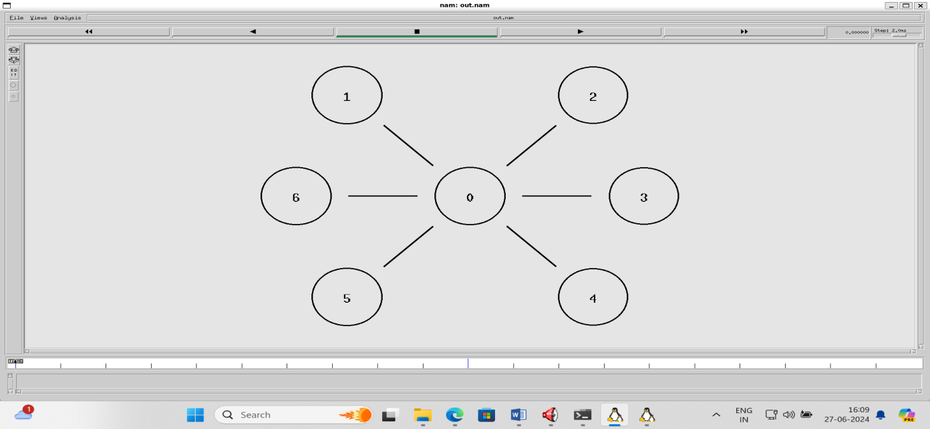

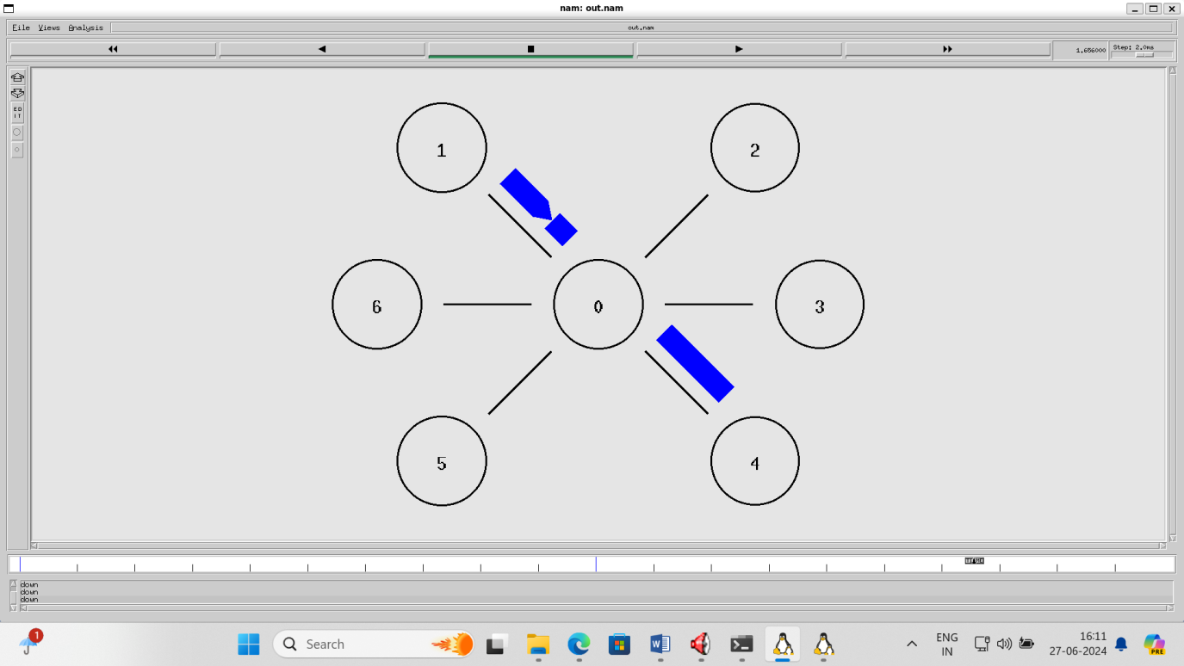

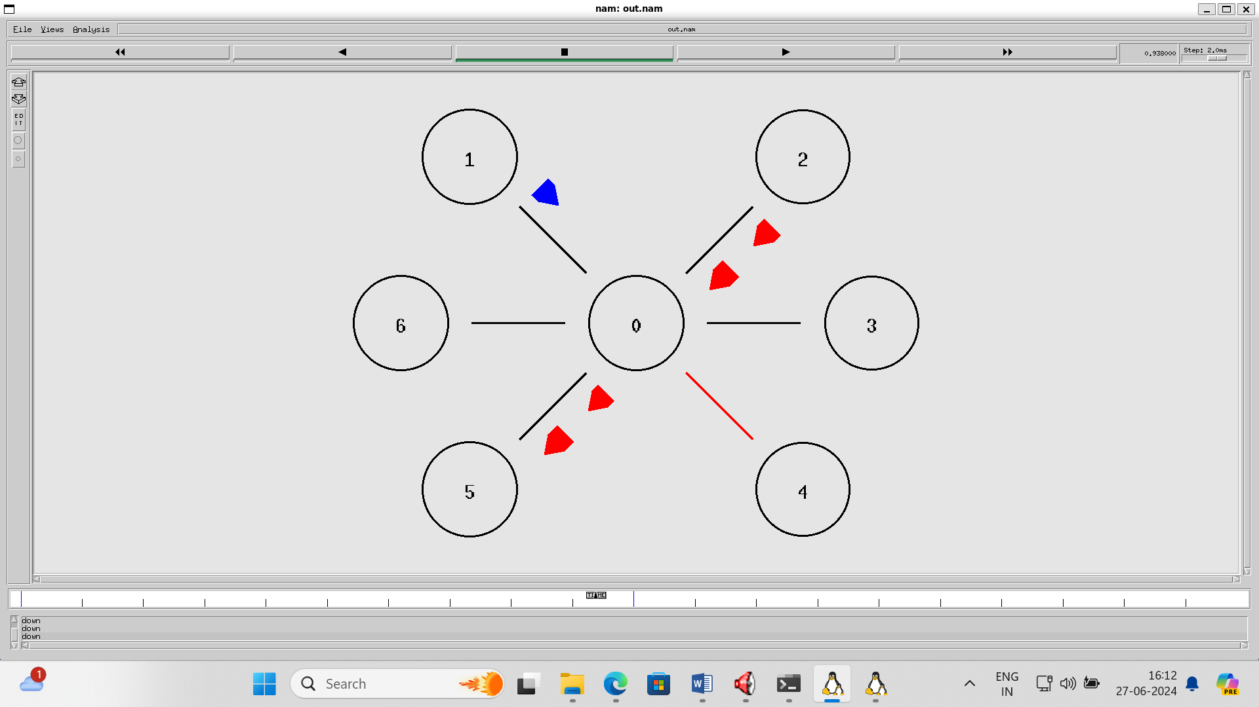

**VIVA QUESTIONS:**

1. What are the Different topologies available in networks?
2. Which topology requires multipoint connection?
3. Datacommunication system with in a campus is called as?
4. What is meant by WAN?
5. Explain the working of Ring topology?

**RESULT:**

The experiment has been conducted successfully.

**EXPERIMENT / PRACTICAL -7**

Simulation of Stop and Wait Protocol, Simulation of Sliding Window Protocol

**a) AIM :**

Simulation of Stop and Wait Protocol

**DESCRIPTION:**

Stop and Waitis a reliable transmission flow control protocol. This protocol works only in Connection Oriented(Point to Point) Transmission. The Source node has window size of ONE. After transmission of a frame thetransmitting (Source) node waits for an Acknowledgement from the destination node. If the transmitted frame reaches the destination without error, the destination transmits a positive acknowledgement. If the transmittedframe reaches the Destination with error, the receiver destination does not transmit an acknowledgement. If thetransmitter receives a positive acknowledgement, it transmits the next frame if any. Else if its acknowledgementreceivetimerexpires, it retransmits the same frame.

1. Start with the window size of 1from the transmitting (Source)node
2. After transmission of a frame the transmitting(Source) node waits for a reply(Acknowledgement) from

the receiving (Destination) node.

1. If the transmitted frame reaches the receiver(Destination) without error, the receiver(Destination)

transmits a Positive Acknowledgement.

1. If the transmitted frame reaches the receiver(Destination)with error,the receiver(Destination) do not

transmit acknowledgement.

1. If the transmitter receives a positive acknowledgement, it transmits the next frame if any. Else if the

transmission timer expires, it retransmits the same frame again.

1. If the transmitted acknowledgment reaches the Transmitter(Destination) without error, the Transmitter

(Destination) transmits the next frame if any.

1. If the transmitted frame reaches the Transmitter(Destination) with error, the Transmitter(Destination)

transmits the same frame.

1. This concept of the Transmitting (Source) node waiting after transmission for a reply from the receiver

is known as STOP and WAIT.

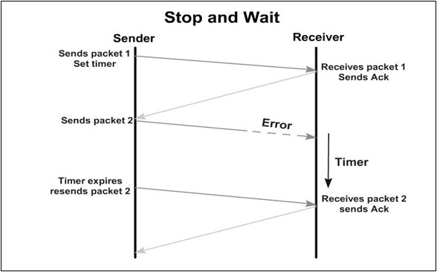

**HARD WARE REQUIREMENTS:**

1. Computer with Configuration – CPU HDD capacity: 250 GB RAM: 4 GB, i3 processor

**SOFTWARE REQUIREMENTS:**

Windows 11 Operating Systems, Ubuntu 20.04 Linux, NS 2.35 Simulator

**ALGORITHM:**

* 1. Create a simulator object
  2. Define different colors for different dataflows
  3. Open a nam trace file and define finish procedure then close the trace file,and execute nam on trace file.
  4. Create two nodes that forms a network numbered 0 and 1
  5. Create duplex links between the nodes n0 and n1
  6. Setup TCP Connection between n0 and n1
  7. Apply CBR Traffic over TCP
  8. Schedule events and run the program.

**SOURCE CODE:**

set ns [new Simulator]

$ns color 1 Blue

# set nam output file

setnf [open out.nam w]

$ns namtrace-all $nf

# destructor

proc finish {} {

global ns nf

$ns flush-trace

close $nf

execnamout.nam&

exit 0

}

# create two new nodes and create labels for them

set n0 [$ns node]

set n1 [$ns node]

$ns at 0.0 "$n0 label \" Sender \" "

$ns at 0.0 "$n1 label \"Receiver\" "

# set up a new duplex link

$ns duplex-link $n0 $n1 1Mb 200ms DropTail

$ns duplex-link-op $n0 $n1 orient right

# create a new TCP agent

settcp [new Agent/TCP]

# attach the agent to first node

$ns attach-agent $n0 $tcp

$tcp set fid_ 1

$tcp set window_ 1

$tcp set maxcwnd_ 1

$ns add-agent-trace $tcptcp

$ns monitor-agent-trace $tcp

settcpsink [new Agent/TCPSink]

$ns attach-agent $n1 $tcpsink

$ns connect $tcp $tcpsink

set ftp [new Application/FTP]

$ftp attach-agent $tcp

$ns at 0.5 "$ftp start"

$ns at 3.0 "$ns detach-agent $n0 $tcp ; $ns detach-agent $n1 $tcpsink "

$ns at 1.0 "$ns trace-annotate \"send packet 1\""

$ns at 1.4 "$ns trace-annotate \"recieveack 1\""

$ns at 2.0 "$ns trace-annotate \"send packet 2\""

$ns at 2.5 "$ns trace-annotate \"receive ack 2\""

$ns at 3.2 "$ns trace-annotate \"send packet 3\""

$ns at 3.5 "$ns trace-annotate \"receive ack 3\""

$ns at 3.8 "$ns trace-annotate \"send packet 4\""

$ns at 4.0 "finish"

$ns run

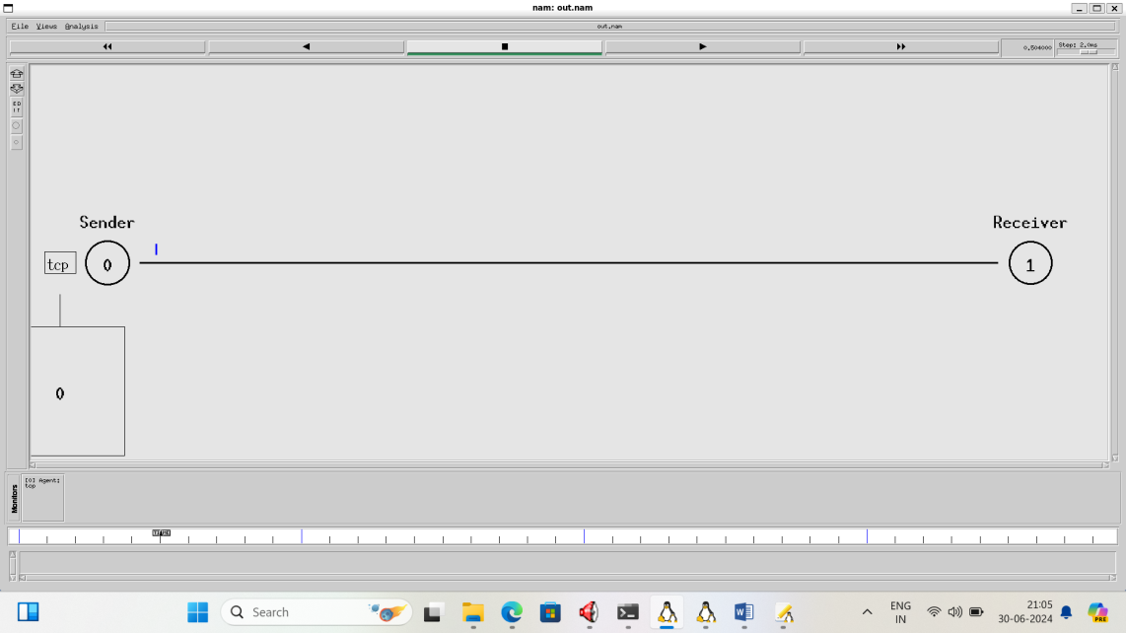

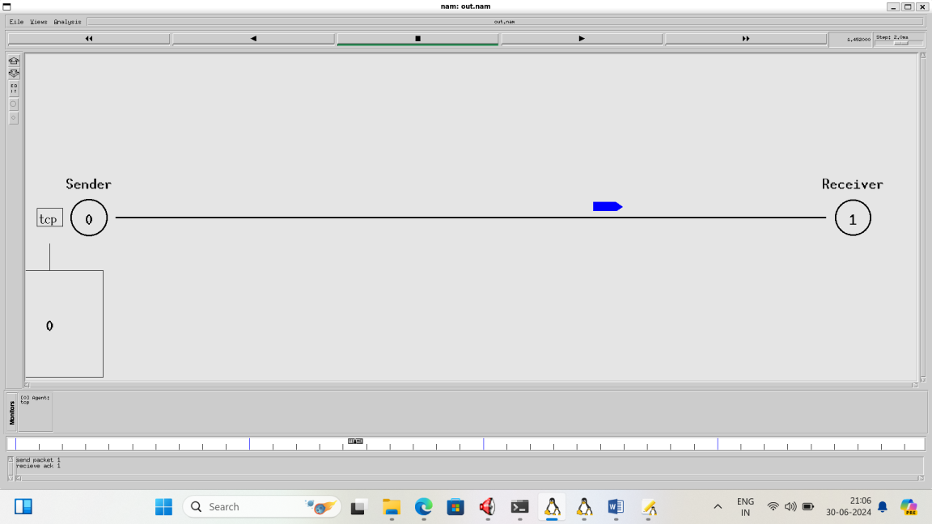

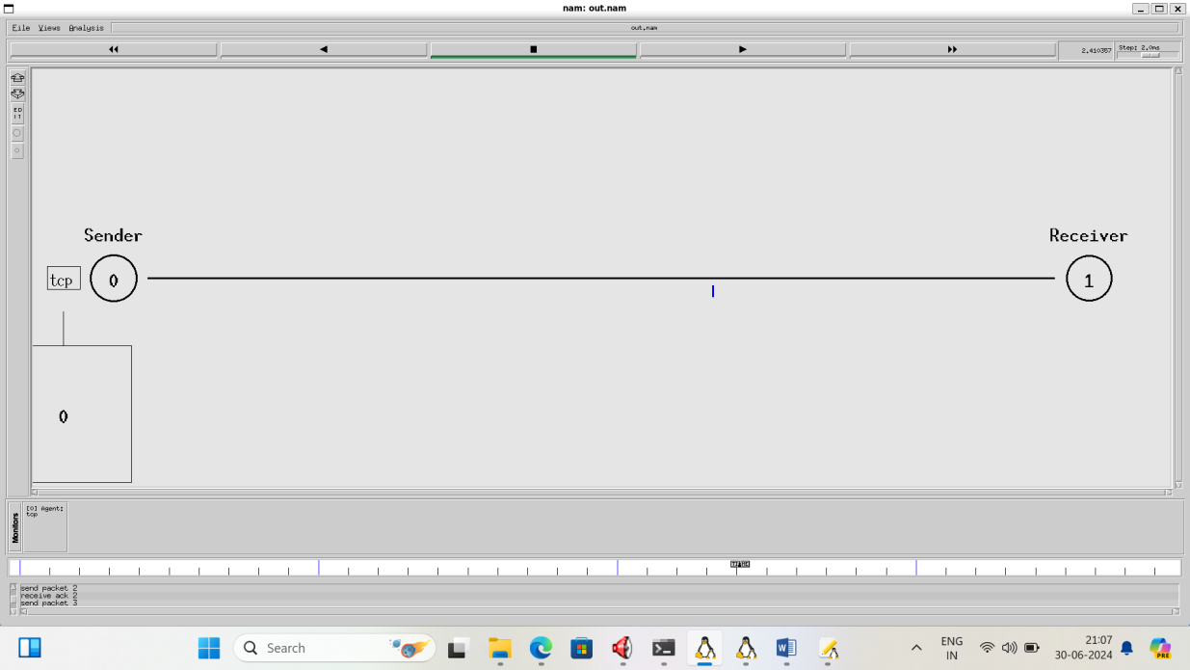

**RESULT:**

The experiment has been conducted successfully.

**b) AIM :**

Simulation of Sliding Window Protocol

**DESCRIPTION:**

A sliding window protocol is a feature of packet-based [data transmission](https://en.wikipedia.org/wiki/Data_transmission) [protocols.](https://en.wikipedia.org/wiki/Protocol_(computing)) Sliding window protocols are used where reliable in-order delivery of packets is required, such as in the [Data Link Layer](https://en.wikipedia.org/wiki/Data_Link_Layer) ([OSI model](https://en.wikipedia.org/wiki/OSI_model)) as well as in the [Transmission Control Protocol](https://en.wikipedia.org/wiki/Transmission_Control_Protocol)(TCP).

Conceptually, each portion of the transmission (packets in most data link layers, but bytes in TCP) is assigned a unique consecutive sequence number, and the receiver uses the numbers to place received packets in the correctorder, discarding duplicate packets and identifying missing ones. The problem with this is that there is no limit on the size of the sequence number that can be required.

By placing limits on the number of packets that can be transmitted or received at any given time, a sliding window protocol allows an unlimited number of packets to be communicated using fixed-size sequence numbers. The term "window" on the transmitter side represents the logical boundary of the total number of packets yet to be acknowledged by the receiver. The receiver informs the transmitter in each acknowledgment packet the current maximum receiver buffer size (window boundary). The TCP header uses a 16-bit field to report the receive window size to the sender. Therefore, the largest window that can be used is 216=64 kilo bytes. In slow-start mode, the transmitter starts with low packet count and increases the number of packets in each transmission after receiving acknowledgment packets from receiver. For every [ack packet](https://en.wikipedia.org/wiki/Acknowledgement_(data_networks)) received, the window slides by one packet (logically) to transmit one new packet. When the window threshold is reached, thetransmitter sends one packet for one ack packet received. If the window limit is 10 packets then in slow start mode the transmitter may start transmitting one packet followed by two packets(before transmitting two packets,one packet ack has to be received), followed by three packets and so on until 10 packets. But after reaching 10 packets, further transmissions are restricted to one packet transmitted for one ack packet received. In a simulation this appears as if the window is moving by one packet distance for every ack packet received.

On the receiver side also, the window moves one packet for every packet received. The sliding window method ensures that traffic [congestion](https://en.wikipedia.org/wiki/Network_congestion) on the network is avoided. The application layer will still be offering data for transmission to TCP without worrying about the network traffic congestion issues as the TCP on sender and receiver side implement sliding windows of packet buffer.The window size may vary dynamically depending on network traffic.

For the highest possible [throughput,](https://en.wikipedia.org/wiki/Throughput) it is important that the transmitter is not forced to stop sending by the sliding window protocol earlier than one [round-trip delay time](https://en.wikipedia.org/wiki/Round-trip_delay_time) (RTT). The limit on the amount of data that it can send before stopping to wait for an [acknowledgment](https://en.wikipedia.org/wiki/Acknowledgement_(data_networks)) should be larger than the [bandwidth-delay product](https://en.wikipedia.org/wiki/Bandwidth-delay_product) of the communications link. If it is not, the protocol will limit the effective [bandwidth](https://en.wikipedia.org/wiki/Bandwidth_(computing)) of the link.

**HARD WARE REQUIREMENTS:**

1. Computer with Configuration – CPU HDD capacity: 250 GB RAM: 4 GB, i3 processor

**SOFTWARE REQUIREMENTS:**

Windows 11 Operating Systems, Ubuntu 20.04 Linux, NS 2.35 Simulator

**ALGORITHM:**

**Sliding Window Protocol Algorithm**

1. **Initialization:**
   * Define the window size W.
   * Initialize sender window: S_window = 0.
   * Initialize receiver window: R_window = 0.
   * Set a timer for each packet.
2. **Sending Data:**
   * The sender can send up to W packets without receiving an acknowledgment (ACK).
   * For each packet i (where i ranges from S_window to S_window + W - 1):
     + Send packet i.
     + Start a timer for packet i.
3. **Receiving Data:**
   * When the receiver receives a packet i:
     + If packet i is within the R_window:
       - Send an acknowledgment (ACK) for packet i.
       - If packet i is the expected packet, move the R_window forward.
     + If packet i is outside the R_window, ignore the packet.
4. **Acknowledgment Handling:**
   * When the sender receives an ACK for packet i:
     + Mark packet i as acknowledged.
     + Slide the sender window S_window forward to the next unacknowledged packet.
5. **Timeout Handling:**
   * If the timer for packet i expires before an ACK is received:
     + Retransmit packet i.
     + Restart the timer for packet i.

**SOURCE CODE:**

set ns [new Simulator]

#puts "Starting program..."

# Creating Output files

setnamf [open stop_wait_protocol.nam w]

$ns namtrace-all $namf

settrf [open stop_wait_protocol.tr w]

$ns trace-all $trf

# Finishing procedures

proc finish {} {

global ns namftrf

$ns flush-trace

#puts "Saving namf and trf..."

close $namf

close $trf

#puts "Opening Network animator..."

execnamstop_wait_protocol.nam&

#puts "Closing program..."

exit 0

}

# Creating nodes

set n0 [$ns node]

set n1 [$ns node]

# Setting links and setting queue size

$ns duplex-link $n0 $n1 0.2Mb 200ms DropTail

$ns duplex-link-op $n0 $n1 orient right

$ns queue-limit $n0 $n1 10

# Defining agents and setting src and dest

settcp [new Agent/TCP]

set sink [new Agent/TCPSink]

$ns attach-agent $n0 $tcp

$ns attach-agent $n1 $sink

$ns connect $tcp $sink

# Creating FTP

set ftp [new Application/FTP]

$ftp attach-agent $tcp

# Stop and wait protocol

$tcp set window_ 1

$tcp set maxcwnd_ 1

# Use below 2 # for sliding window

#$tcp set windowInit_ 4

#$tcp set maxcwnd_ 4

# I dont know what these are.

$tcp set nam_tracevar_ true

$ns add-agent-trace $tcptcp

$ns monitor-agent-trace $tcp

$tcptracevarcwnd_

# Finishing and closing procedures

$ns at 0.1 "$ftp start"

$ns at 3.0 "$ns detach-agent $n0 $tcp"

$ns at 3.0 "$ns detach-agent $n1 $sink"

$ns at 3.5 "$ftp stop"

$ns at 5.0 "finish"

$ns run

**OUTPUT:**

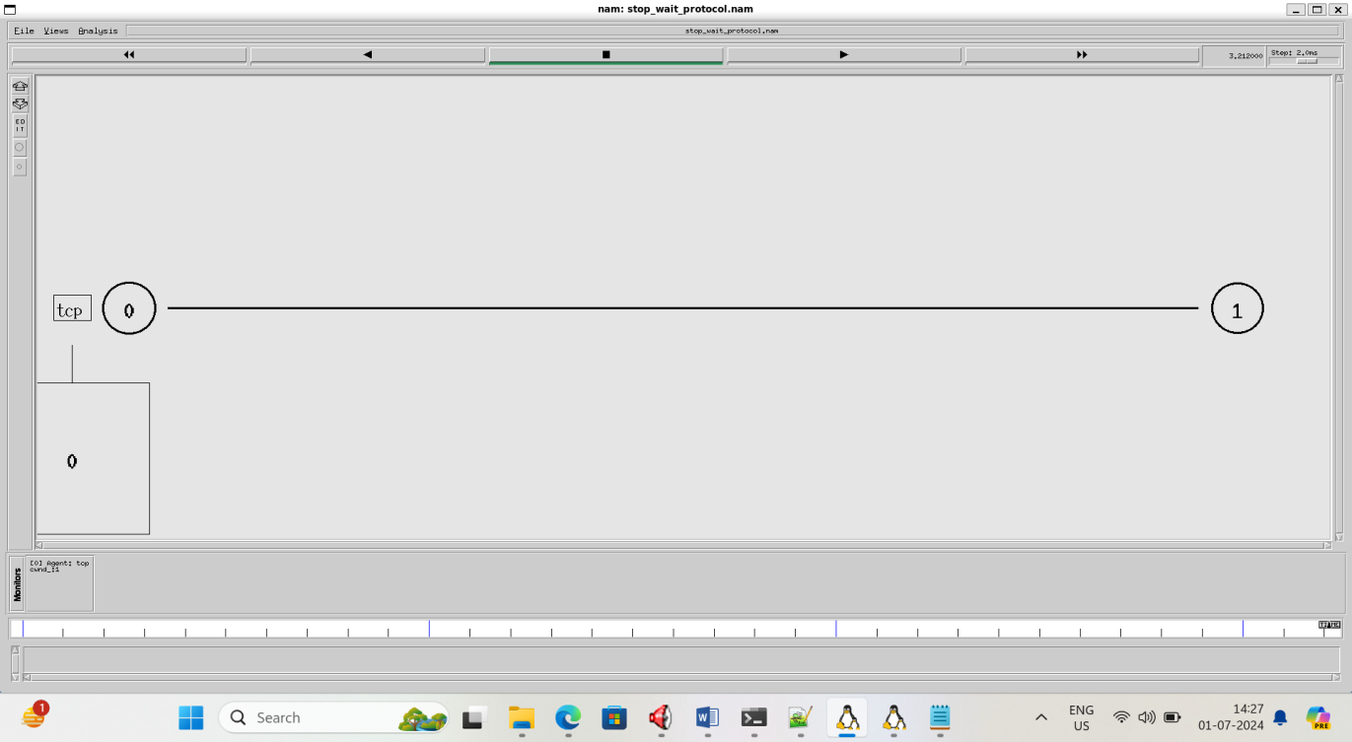

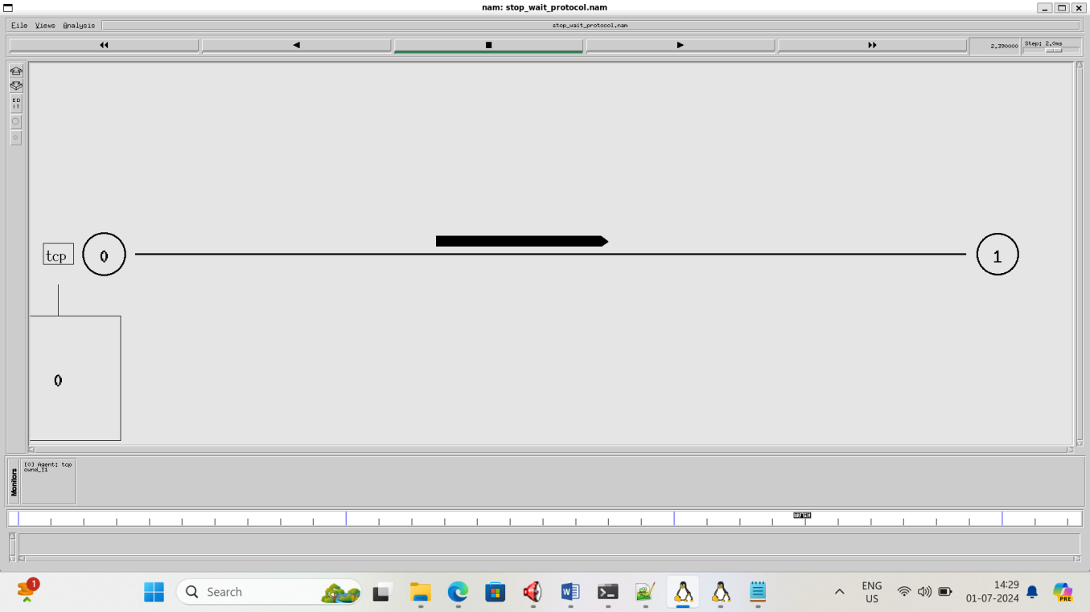

**VIVA QUESTIONS:**

1. What is ARQ?
2. What is stop and wait protocol?
3. What is stop and wait ARQ?
4. What is usage of sequence number in reliable transmission?
5. Whatis sliding window?

**RESULT:**

The experiment has been conducted successfully.

**EXPERIMENT / PRACTICAL -8**

Simulation of the Routing algorithms (LSR/DVR)

# AIM:

# Simulation of Distance Vector/Link State Routing.

# DESCRIPTION:

**Distance Vector routing protocol**

Routing is the process of selecting best paths in a network.In the past, the termrouting was also used to mean forwarding network traffic among networks. However this latter function is much better described as simply forwarding. Routing is performed for many kinds of networks, including the telephone network (circuit switching), electronic data networks (such as the Internet), and transportation networks. This article is concerned primarily with routing in electronic data networks using packet switching technology. In packet switching networks, routing directs packet forwarding (the transit of logically addressed network packets from their source toward their ultimate destination) through intermediate nodes. Intermediate nodes are typically network hardware devices such asrouters, bridges, gateways, firewalls, or switches. General-purpose computers can also forward packets and perform routing, though they are not specialized hardware and may suffer from limited performance. The routing process usually directs forwarding on the basis of routing tables which maintain are cord of the routes to various network destinations. Thus, constructing routing tables, which are held in the router's memory, is very important for efficient routing. Most routing algorithms use only one network path at a time. Multi path routing techniques enable the use of multiple alternative paths. Incase of overlapping/equal routes, the following elements are considered in order to decide which routes get installed into the routing table(sorted by priority):

1. Prefix-Length: where longer subnet masks are preferred (independent of whether it is within a routing protocol or over different routing protocol)
2. Metric: where a lower metric/cost is preferred (only valid within one and the Same routing

protocol)

1. Administrative distance: where a lower distance is preferred(only valid between different routing protocols)Routing, in a more narrow sense of the term, is often contrasted with bridging in its assumption that network addresses are structured and that similar addresses imply proximity within the network. Structured addresses allow a single routing table entry to represent the route to a group of devices. In large networks, structured addressing(routing, in the narrow sense)out performs unstructured addressing(bridging). Routing has become the dominant form of addressing on the Internet. Bridging is still widely used within localized environments.

# ALGORITHM:

There are several variants of flooding algorithm. Most work roughly as follows:

1. Each node acts as both a transmitter and a receiver.
2. Each node tries to forward every message to every one of its neighbours except the source node. This result sin every message eventually being delivered to all reachable parts of the network. Algorithms may need to be more complex than this, since, in some case,precautions have to be taken to avoid wasted duplicate deliveries and infinite loops, and to allow messages to eventually expire from the system. A variant of flooding called selective flooding partially addresses these issues by only sending packets to routers in the same direction.In selective flooding the routers don't send every incoming packet on everyline but only on those lines which are going approximately in the right direction.

# PROGRAM:

setns[newSimulator]

setnf[openout.namw]

$nsnamtrace-all$nf

settr[openout.trw]

$nstrace-all$tr

procfinish{}{

globalnfnstr

$nsflush-trace

close$tr

execnamout.nam&

exit0

}

set n0 [$ns node]set n1 [$ns node]set n2 [$ns node]setn3[$nsnode]

$nsduplex-link $n0$n110Mb10msDropTail

$nsduplex-link $n1$n310Mb10msDropTail

$nsduplex-link $n2$n110Mb10msDropTail

$nsduplex-link-op$n0$n1orientright-down

$nsduplex-link-op $n1$n3orientright

$nsduplex-link-op$n2$n1 orientright-up

settcp[newAgent/TCP]

$nsattach-agent$n0$tcp

setftp[newApplication/FTP]

$ftpattach-agent$tcp

setsink[newAgent/TCPSink]

$nsattach-agent$n3$sink

setudp [newAgent/UDP]

$nsattach-agent$n2$udp

setcbr[newApplication/Traffic/CBR]

$cbrattach-agent$udp

setnull[newAgent/Null]

$nsattach-agent$n3$null

$nsconnect$tcp$sink

$nsconnect$udp$null

$nsrtmodel-at1.0down $n1$n3

$nsrtmodel-at2.0up$n1$n3

$nsrtprotoDV

$nsat 0.0 "$ftpstart"

$nsat 0.0 "$cbrstart"

$nsat 5.0"finish"

$nsrun

**RESULT:**

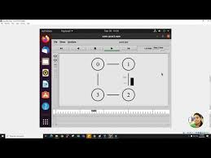

**EXPERIMENT / PRACTICAL -9**

Simulation of data transmission using TCP and evaluate the performance metric (Packet delivery ratio, Throughput, Jitter/Average end to end delay)

**AIM:**

Simulation of data transmission using TCP and evaluate the performance metric (Packet delivery ratio, Throughput, Jitter/Average end to end delay)

**CODE:**

# Create a simulator object

set ns [new Simulator]

# Define different colors

# for data flows (for NAM)

$ns color 1 Blue

$ns color 2 Red

# Open the NAM trace file

setnf [open out.nam w]

$ns namtrace-all $nf

# Define a 'finish' procedure

proc finish {} {

global ns nf

$ns flush-trace

# Close the NAM trace file

close $nf

# Execute NAM on the trace file

execnamout.nam&

exit 0

}

# Create four nodes

set n0 [$ns node]

set n1 [$ns node]

set n2 [$ns node]

set n3 [$ns node]

# Create links between the nodes

$ns duplex-link $n0 $n2 2Mb 10ms DropTail

$ns duplex-link $n1 $n2 2Mb 10ms DropTail

$ns duplex-link $n2 $n3 1.7Mb 20ms DropTail

# Set Queue Size of link (n2-n3) to 10

$ns queue-limit $n2 $n3 10

# Give node position (for NAM)

$ns duplex-link-op $n0 $n2 orient right-down

$ns duplex-link-op $n1 $n2 orient right-up

$ns duplex-link-op $n2 $n3 orient right

# Monitor the queue for link (n2-n3). (for NAM)

$ns duplex-link-op $n2 $n3 queuePos 0.5

# Setup a TCP connection

settcp [new Agent/TCP]

$tcp set class_ 2

$ns attach-agent $n0 $tcp

set sink [new Agent/TCPSink]

$ns attach-agent $n3 $sink

$ns connect $tcp $sink

$tcp set fid_ 1

# Setup a FTP over TCP connection

set ftp [new Application/FTP]

$ftp attach-agent $tcp

$ftp set type_ FTP

/* # Setup a UDP connection

setudp [new Agent/UDP]

$ns attach-agent $n1 $udp

set null [new Agent/Null] */

$ns attach-agent $n3 $null

$ns connect $udp $null

$udp set fid_ 2

# Setup a CBR over UDP connection

setcbr [new Application/Traffic/CBR]

$cbr attach-agent $udp

$cbr set type_ CBR

$cbr set packet_size_ 1000

$cbr set rate_ 1mb

$cbr set random_ false

# Schedule events for the CBR and FTP agents

$ns at 0.1 "$cbr start"

$ns at 1.0 "$ftp start"

$ns at 4.0 "$ftp stop"

$ns at 4.5 "$cbr stop"

# Detachtcp and sink agents

# (not really necessary)

$ns at 4.5 "$ns detach-agent $n0 $tcp ; $ns detach-agent $n3 $sink"

# Call the finish procedure after

# 5 seconds of simulation time

$ns at 5.0 "finish"

# Print CBR packet size and interval

puts "CBR packet size = [$cbr set packet_size_]"

puts "CBR interval = [$cbr set interval_]"

# Run the simulation

$ns run

**OUTPUT:**

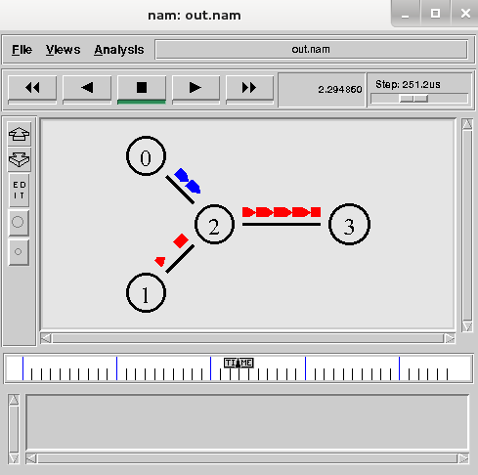

**EXPERIMENT / PRACTICAL -10**

Simulation of data transmission using UDP and evaluate the performance metric (Packet delivery ratio, Throughput, Jitter/Average end to end delay)

**AIM:**

Simulation of data transmission using UDP and evaluate the performance metric (Packet delivery ratio, Throughput, Jitter/Average end to end delay)

**CODE:**

# Create a simulator object

set ns [new Simulator]

# Define different colors

# for data flows (for NAM)

$ns color 1 Blue

$ns color 2 Red

# Open the NAM trace file

setnf [open out.nam w]

$ns namtrace-all $nf

# Define a 'finish' procedure

proc finish {} {

global ns nf

$ns flush-trace

# Close the NAM trace file

close $nf

# Execute NAM on the trace file

execnamout.nam&

exit 0

}

# Create four nodes

set n0 [$ns node]

set n1 [$ns node]

set n2 [$ns node]

set n3 [$ns node]

# Create links between the nodes

$ns duplex-link $n0 $n2 2Mb 10ms DropTail

$ns duplex-link $n1 $n2 2Mb 10ms DropTail

$ns duplex-link $n2 $n3 1.7Mb 20ms DropTail

# Set Queue Size of link (n2-n3) to 10

$ns queue-limit $n2 $n3 10

# Give node position (for NAM)

$ns duplex-link-op $n0 $n2 orient right-down

$ns duplex-link-op $n1 $n2 orient right-up

$ns duplex-link-op $n2 $n3 orient right

# Monitor the queue for link (n2-n3). (for NAM)

$ns duplex-link-op $n2 $n3 queuePos 0.5

set sink [new Agent/TCPSink]

$ns attach-agent $n3 $sink

$ns connect $tcp $sink

$tcp set fid_ 1

# Setup a FTP over TCP connection

set ftp [new Application/FTP]

$ftp attach-agent $tcp

$ftp set type_ FTP

# Setup a UDP connection

setudp [new Agent/UDP]

$ns attach-agent $n1 $udp

set null [new Agent/Null]

$ns attach-agent $n3 $null

$ns connect $udp $null

$udp set fid_ 2

# Setup a CBR over UDP connection

setcbr [new Application/Traffic/CBR]

$cbr attach-agent $udp

$cbr set type_ CBR

$cbr set packet_size_ 1000

$cbr set rate_ 1mb

$cbr set random_ false

# Schedule events for the CBR and FTP agents

$ns at 0.1 "$cbr start"

$ns at 1.0 "$ftp start"

$ns at 4.0 "$ftp stop"

$ns at 4.5 "$cbr stop"

# Detachtcp and sink agents

# (not really necessary)

$ns at 4.5 "$ns detach-agent $n0 $tcp ; $ns detach-agent $n3 $sink"

# Call the finish procedure after

# 5 seconds of simulation time

$ns at 5.0 "finish"

# Print CBR packet size and interval

puts "CBR packet size = [$cbr set packet_size_]"

puts "CBR interval = [$cbr set interval_]"

# Run the simulation

$ns run

**OUTPUT:**



**EXPERIMENT / PRACTICAL -11**

Implement Socket Programming.

**AIM:**

Implement Socket Programming.

**DESCRIPTION:**

**TCP Client-Server Implementation in C**

[4th September 2021](https://idiotdeveloper.com/2021/09/) [[https://secure.gravatar.com/avatar/84792d809bfb3658402dfa8960e90453?s=50&d=mm&r=g](https://idiotdeveloper.com/author/nktomar39/)Nikhil Tomar](https://idiotdeveloper.com/author/nktomar39/)

In this tutorial, you will learn to implement a TCP client-server program in the C programming language. Here, the client and server would exchange messages and communicate with each other in an interactive way. In addition, you will also learn about the client-server architecture and other related concepts.

**Table of Content**

1. What is a socket?
2. What is TCP?
3. Client-server Architecture.
4. Implementation
5. Further Reading
6. Summary

**What is a Socket?**

A socket is a structure that allows communication between different processes on the same computer or different computers. A socket allows us to communicate by sending and receiving data over the network. In simple terms, it is a way for a computer to talk to other computers on the network.

A socket is one endpoint of a two-way communication link between two programs running on the network. A socket is bound to a port number so that the TCP layer can identify the application that data is destined to be sent to.

https://docs.oracle.com/javase/tutorial/networking/sockets/definition.html

**What is TCP?**

TCP refers to the Transmission Control Protocol. It is one of the main protocol used for communication over the internet. Some of the features of this protocol are:

* It is a connection-oriented communication protocol.
* It used three-way handshake to establish reliable connections.
* TCP gurantees the delivery of the data packets.

**Client-server Architecture**

A client-server architecture is a model in computer networking, where the server provides some service to the client. In this architecture, the client computer sends a request to the server computer through a network (internet). The server accepts this request and sends the required data to the client.In simple terms, we can say

* Server is a remote computer which provides some services.
* Client is the one that request the server for these services.

**Implementation**

Here, we will start the implementation of the client-server implementation in C. First, we start by implementing the server-side and then we begin with the client-side code.

**SERVER-SIDE CODE**

|  |  |
| --- | --- |
| 1  2  3  4  5  6  7  8  9  10  11  12  13  14  15  16  17  18  19  20  21  22  23  24  25  26  27  28  29  30  31  32  33  34  35  36  37  38  39  40  41  42  43  44  45  46  47  48  49  50  51  52  53  54  55  56  57  58  59 | #include <stdio.h>  #include <stdlib.h>  #include <string.h>  #include <unistd.h>  #include <arpa/inet.h>    int main(){      char *ip = "127.0.0.1";    int port = 5566;      intserver_sock, client_sock;    structsockaddr_inserver_addr, client_addr;    socklen_taddr_size;    char buffer[1024];    int n;      server_sock = socket(AF_INET, SOCK_STREAM, 0);    if (server_sock< 0){      perror("[-]Socket error");      exit(1);    }    printf("[+]TCP server socket created.\n");      memset(&server_addr, '\0', sizeof(server_addr));    server_addr.sin_family = AF_INET;    server_addr.sin_port = port;    server_addr.sin_addr.s_addr = inet_addr(ip);      n = bind(server_sock, (structsockaddr*)&server_addr, sizeof(server_addr));    if (n < 0){      perror("[-]Bind error");      exit(1);    }    printf("[+]Bind to the port number: %d\n", port);      listen(server_sock, 5);    printf("Listening...\n");      while(1){      addr_size = sizeof(client_addr);      client_sock = accept(server_sock, (structsockaddr*)&client_addr, &addr_size);      printf("[+]Client connected.\n");        bzero(buffer, 1024);      recv(client_sock, buffer, sizeof(buffer), 0);      printf("Client: %s\n", buffer);        bzero(buffer, 1024);      strcpy(buffer, "HI, THIS IS SERVER. HAVE A NICE DAY!!!");      printf("Server: %s\n", buffer);      send(client_sock, buffer, strlen(buffer), 0);        close(client_sock);      printf("[+]Client disconnected.\n\n");      }    return 0;  } |

The server-side process can be broken down into the following steps:

1. socket() – create TCP socket.
2. bind() – bind the TCP socket to the server address (ip and port).
3. listen() – waiting for the clients.
4. accept() – connection is established between the client and server.
5. recv() and send () – communicate with each other.
6. close() – close the connection from the client.

Include the required header files.

|  |  |
| --- | --- |
| 1  2  3  4  5 | #include <stdio.h>  #include <stdlib.h>  #include <string.h>  #include <unistd.h>  #include <arpa/inet.h> |

Define the IP (Internet Protocol) address and port number, that would be used to create a socket. Here, we are using the localhost address for both the server and the client.

|  |  |
| --- | --- |
| 1  2 | char *ip = "127.0.0.1";  int port = 5566; |

Here, we define the required variables used later in this program.

|  |  |
| --- | --- |
| 1  2  3  4  5 | intserver_sock, client_sock;  structsockaddr_inserver_addr, client_addr;  socklen_taddr_size;  char buffer[1024];  int n; |

Create a TCP (Transmission Control Protocol) socket that returns a socket descriptor. This socket descriptor would be used to communicate with the client.

|  |  |
| --- | --- |
| 1  2  3  4  5  6 | server_sock = socket(AF_INET, SOCK_STREAM, 0);  if (server_sock< 0){    perror("[-]Socket error");    exit(1);  }  printf("[+]TCP server socket created.\n"); |

Here, we initialize the server address by providing the required IP and port number. The server keeps all the address information for both the server and the client in the sockaddr_in struct.

|  |  |
| --- | --- |
| 1  2  3  4 | memset(&server_addr, '\0', sizeof(server_addr));  server_addr.sin_family = AF_INET;  server_addr.sin_port = port;  server_addr.sin_addr.s_addr = inet_addr(ip); |

Binding the socket descriptor with the server address information.

|  |  |
| --- | --- |
| 1  2  3  4  5  6 | n = bind(server_sock, (structsockaddr*)&server_addr, sizeof(server_addr));  if (n < 0){  perror("[-]Bind error");  exit(1);  }  printf("[+]Bind to the port number: %d\n", port); |

Now, we listen for incoming connections from the clients.

|  |  |
| --- | --- |
| 1  2 | listen(server_sock, 5);  printf("Listening...\n"); |

The server handles only one client at a time. So, only one client would communicate and the rest would have to wait for the communication to get completed.

|  |  |
| --- | --- |
| 1  2  3  4  5  6  7  8  9  10  11  12  13  14  15  16  17 | while(1){    addr_size = sizeof(client_addr);    client_sock = accept(server_sock, (structsockaddr*)&client_addr, &addr_size);    printf("[+]Client connected.\n");      bzero(buffer, 1024);    recv(client_sock, buffer, sizeof(buffer), 0);    printf("Client: %s\n", buffer);      bzero(buffer, 1024);    strcpy(buffer, "HI, THIS IS SERVER. HAVE A NICE DAY!!!");    printf("Server: %s\n", buffer);    send(client_sock, buffer, strlen(buffer), 0);      close(client_sock);    printf("[+]Client disconnected.\n\n");    } |

To communicate with all the clients, we start a while loop and the following things happen:

* Accept the client connection.
* We receive a message from the client and print it on the console.
* Next, the server send a reply message to the client.
* Close connection from the client.

The following sequences go on with other clients.

**CLIENT-SIDE CODE**

|  |  |
| --- | --- |
| 1  2  3  4  5  6  7  8  9  10  11  12  13  14  15  16  17  18  19  20  21  22  23  24  25  26  27  28  29  30  31  32  33  34  35  36  37  38  39  40  41  42  43  44  45  46 | #include <stdio.h>  #include <stdlib.h>  #include <string.h>  #include <unistd.h>  #include <arpa/inet.h>    int main(){      char *ip = "127.0.0.1";    int port = 5566;      int sock;    structsockaddr_inaddr;    socklen_taddr_size;    char buffer[1024];    int n;      sock = socket(AF_INET, SOCK_STREAM, 0);    if (sock < 0){      perror("[-]Socket error");      exit(1);    }    printf("[+]TCP server socket created.\n");      memset(&addr, '\0', sizeof(addr));    addr.sin_family = AF_INET;    addr.sin_port = port;    addr.sin_addr.s_addr = inet_addr(ip);      connect(sock, (structsockaddr*)&addr, sizeof(addr));    printf("Connected to the server.\n");      bzero(buffer, 1024);    strcpy(buffer, "HELLO, THIS IS CLIENT.");    printf("Client: %s\n", buffer);    send(sock, buffer, strlen(buffer), 0);      bzero(buffer, 1024);    recv(sock, buffer, sizeof(buffer), 0);    printf("Server: %s\n", buffer);      close(sock);    printf("Disconnected from the server.\n");      return 0;  } |

The client-side process can be broken down into the following steps:

1. socket() – create TCP socket.
2. connect() – connect to the server.
3. recv() and send () – communicate with each other.
4. close() – close the connection.

We begin by including all the required header files, defining the IP (Internet Protocol) address and the port number. We also define the required variable used later in this program.

|  |  |
| --- | --- |
| 1  2  3  4  5 | #include <stdio.h>  #include <stdlib.h>  #include <string.h>  #include <unistd.h>  #include <arpa/inet.h> |

**NOTE:** Make sure that the IP address and the port number for the client are the same as the server.

|  |  |
| --- | --- |
| 1  2  3  4  5  6  7  8 | char *ip = "127.0.0.1";  int port = 5566;    int sock;  structsockaddr_inaddr;  socklen_taddr_size;  char buffer[1024];  int n; |

We start by creating a TCP (Transmission Control Protocol) socket. The socket would be used to connect to the server and start communication.

|  |  |
| --- | --- |
| 1  2  3  4  5  6 | sock = socket(AF_INET, SOCK_STREAM, 0);  if (sock < 0){    perror("[-]Socket error");    exit(1);  }  printf("[+]TCP server socket created.\n"); |

We provide the required IP address and the port number to the required data structures.

|  |  |
| --- | --- |
| 1  2  3  4 | memset(&addr, '\0', sizeof(addr));  addr.sin_family = AF_INET;  addr.sin_port = port;  addr.sin_addr.s_addr = inet_addr(ip); |

We send a connection request to the server and wait for the server to accept the request.

|  |  |
| --- | --- |
| 1  2 | connect(sock, (structsockaddr*)&addr, sizeof(addr));  printf("Connected to the server.\n"); |

We send a message to the server and wait for the reply.

|  |  |
| --- | --- |
| 1  2  3  4 | bzero(buffer, 1024);  strcpy(buffer, "HELLO, THIS IS CLIENT.");  printf("Client: %s\n", buffer);  send(sock, buffer, strlen(buffer), 0); |

We receive the reply from the server and print it on the console.

|  |  |
| --- | --- |
| 1  2  3 | bzero(buffer, 1024);  recv(sock, buffer, sizeof(buffer), 0);  printf("Server: %s\n", buffer); |

At last, we close the connection from the server.

|  |  |
| --- | --- |
| 1  2 | close(sock);  printf("Disconnected from the server.\n"); |

**Server.c**

#include <stdio.h>

#include <stdlib.h>

#include <string.h>

#include <unistd.h>

#include <arpa/inet.h>

int main(){

  char *ip = "127.0.0.1";

  int port = 5566;

  int server_sock, client_sock;

  struct sockaddr_in server_addr, client_addr;

  socklen_t addr_size;

  char buffer[1024];

  int n;

  server_sock = socket(AF_INET, SOCK_STREAM, 0);

  if (server_sock < 0){

    perror("[-]Socket error");

    exit(1);

  }

  printf("[+]TCP server socket created.\n");

  memset(&server_addr, '\0', sizeof(server_addr));

  server_addr.sin_family = AF_INET;

  server_addr.sin_port = port;

  server_addr.sin_addr.s_addr = inet_addr(ip);

  n = bind(server_sock, (struct sockaddr*)&server_addr, sizeof(server_addr));

  if (n < 0){

    perror("[-]Bind error");

    exit(1);

  }

  printf("[+]Bind to the port number: %d\n", port);

  listen(server_sock, 5);

  printf("Listening...\n");

  while(1){

    addr_size = sizeof(client_addr);

    client_sock = accept(server_sock, (struct sockaddr*)&client_addr, &addr_size);

    printf("[+]Client connected.\n");

    bzero(buffer, 1024);

    recv(client_sock, buffer, sizeof(buffer), 0);

    printf("Client: %s\n", buffer);

    bzero(buffer, 1024);

    strcpy(buffer, "HI, THIS IS SERVER. HAVE A NICE DAY!!!");

    printf("Server: %s\n", buffer);

    send(client_sock, buffer, strlen(buffer), 0);

    close(client_sock);

    printf("[+]Client disconnected.\n\n");

  }

  return 0;

}

**Client.c**

#include <stdio.h>

#include <stdlib.h>

#include <string.h>

#include <unistd.h>

#include <arpa/inet.h>

int main(){

  char *ip = "127.0.0.1";

  int port = 5566;

  int sock;

  struct sockaddr_in addr;

  socklen_t addr_size;

  char buffer[1024];

  int n;

  sock = socket(AF_INET, SOCK_STREAM, 0);

  if (sock < 0){

    perror("[-]Socket error");

    exit(1);

  }

  printf("[+]TCP server socket created.\n");

  memset(&addr, '\0', sizeof(addr));

  addr.sin_family = AF_INET;

  addr.sin_port = port;

  addr.sin_addr.s_addr = inet_addr(ip);

  connect(sock, (struct sockaddr*)&addr, sizeof(addr));

  printf("Connected to the server.\n");

  bzero(buffer, 1024);

  strcpy(buffer, "HELLO, THIS IS CLIENT.");

  printf("Client: %s\n", buffer);

  send(sock, buffer, strlen(buffer), 0);

  bzero(buffer, 1024);

  recv(sock, buffer, sizeof(buffer), 0);

  printf("Server: %s\n", buffer);

  close(sock);

  printf("Disconnected from the server.\n");

  return 0;

}

**EXPERIMENT / PRACTICAL -12**

Implement SMTP protocol.

**AIM:**

Implement SMTP protocol

**DESCRIPTION:**

Simple Mail Transfer Protocol (SMTP)

Pre-Requisite: Application Layer

Email is emerging as one of the most valuable services on the internet today. Most internet systems use SMTP as a method to transfer mail from one user to another. SMTP is a push protocol and is used to send the mail whereas [POP (post office protocol)](https://www.geeksforgeeks.org/pop-full-form/) or IMAP (internet message access protocol) is used to retrieve those emails at the receiver’s side.

**SMTP Fundamentals**

SMTP is an application layer protocol. The client who wants to send the mail opens a [TCP](https://www.geeksforgeeks.org/what-is-transmission-control-protocol-tcp/) connection to the SMTP server and then sends the mail across the connection. The SMTP server is an always-on listening mode. As soon as it listens for a TCP connection from any client, the SMTP process initiates a connection through port 25. After successfully establishing a TCP connection the client process sends the mail instantly.

**SMTP Protocol**

The SMTP model is of two types:

1. End-to-end method
2. Store-and-forward method

The end-to-end model is used to communicate between different organizations whereas the store and forward method is used within an organization. An SMTP client who wants to send the mail will contact the destination’s host SMTP directly, in order to send the mail to the destination. The SMTP server will keep the mail to itself until it is successfully copied to the receiver’s SMTP.

The client SMTP is the one that initiates the session so let us call it the client-SMTP and the server SMTP is the one that responds to the session request so let us call it receiver-SMTP. The client-SMTP will start the session and the receiver SMTP will respond to the request.

**Model of SMTP System**

In the SMTP model user deals with the user agent (UA), for example, Microsoft Outlook, Netscape, Mozilla, etc. In order to exchange the mail using TCP, MTA is used. The user sending the mail doesn’t have to deal with MTA as it is the responsibility of the system admin to set up a local MTA. The MTA maintains a small queue of mail so that it can schedule repeat delivery of mail in case the receiver is not available. The MTA delivers the mail to the mailboxes and the information can later be downloaded by the user agents.

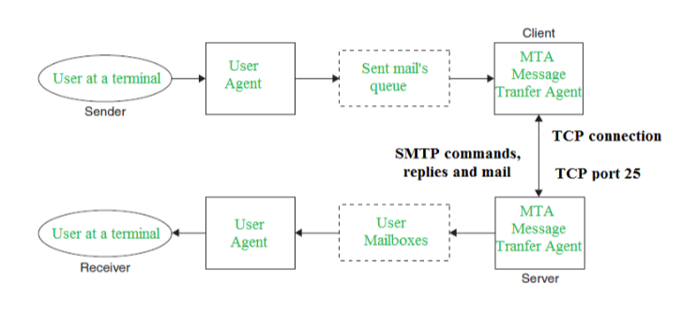

*SMTP Model*

Components of SMTP

1. Mail User Agent (MUA)
2. Mail Submission Agent (MSA)
3. Mail Transfer Agent (MTA)
4. Mail Delivery Agent (MDA)

**1. Mail User Agent (MUA):** It is a computer application that helps you in sending and retrieving mail. It is responsible for creating email messages for transfer to the mail transfer agent(MTA).

**2. Mail Submission Agent (MSA):** It is a computer program that basically receives mail from a Mail User Agent(MUA) and interacts with the Mail Transfer Agent(MTA) for the transfer of the mail.

**3. Mail Transfer Agent(MTA):**It is basically software that has the work to transfer mail from one system to another with the help of SMTP.

**4. Mail Delivery Agent(MDA): A mail** Delivery agent or Local Delivery Agent is basically a system that helps in the delivery of mail to the local system.

**Working of SMTP**

**1. Communication between the sender and the receiver :** The sender’s user agent prepares the message and sends it to the MTA. The MTA’s responsibility is to transfer the mail across the network to the receiver’s MTA. To send mail, a system must have a client MTA, and to receive mail, a system must have a server MTA.

**2. Sending Emails:** Mail is sent by a series of request and response messages between the [client and the server](https://www.geeksforgeeks.org/client-server-model/). The message which is sent across consists of a header and a body. A null line is used to terminate the mail header and everything after the null line is considered the body of the message, which is a sequence of ASCII characters. The message body contains the actual information read by the receipt.

**3. Receiving Emails:** The user agent on the server-side checks the mailboxes at a particular time of intervals. If any information is received, it informs the user about the mail. When the user tries to read the mail it displays a list of emails with a short description of each mail in the mailbox. By selecting any of the mail users can view its contents on the terminal.

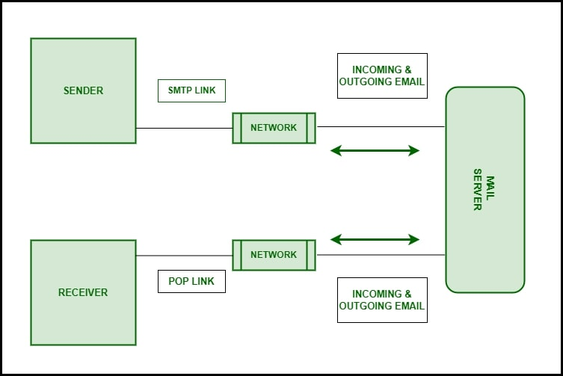

*Working of SMTP*

**Some SMTP Commands**

* HELO – Identifies the client to the server, fully qualified domain name, only sent once per

session

* MAIL – Initiate a message transfer, the fully qualified domain of the originator
* RCPT – Follows MAIL, identifies an addressee, typically the fully qualified name of the

addressee, and for multiple addressees use one RCPT for each addressee

* DATA – send data line by line

For more, you can refer to [SMTP Commands](https://www.geeksforgeeks.org/smtp-commands/).

**DIFFERENCE BETWEEN SMTP AND EXTENDED SMTP**

[Extended STMP](https://www.geeksforgeeks.org/what-is-esmtp-extended-simple-mail-transfer-protocol/) is an extended version of SMTP. Extended SMTP is a set of protocols for sending and receiving electronic messages on the internet. First, Email is sent from sender to sender-server through ESTMP and from sender-server to receiver-server on the internet through ESTMP. ESMTP follows the same protocols as SMTP. It adds more functionality, security, and authentication than SMTP.

Let’s see some basic differences between them.

| **SMTP** | **Extended SMTP** |
| --- | --- |
| Users were not verified in SMTP as a result of massive-scale scam emails being sent. | In Extended SMTP, authentication of the sender is done. |
| We cannot attach a Multimedia file in SMTP directly without the help of MMIE. | We can directly attach Multimedia FIle in ESMTP. |
| We cannot reduce the size of the email in Extended SMTP. | We can reduce the size of the email in Extended SMTP. |
| SMTP clients open transmission with the command HELO. | The main identification feature for ESMTP clients is to open a transmission with the command EHLO (Extended HELLO). |

**ADVANTAGES OF SMTP**

* If necessary, the users can have a dedicated server.
* It allows for bulk mailing.
* Low cost and wide coverage area.
* Offer choices for email tracking.
* Reliable and prompt email delivery.

**DISADVANTAGES OF SMTP**

* SMTP’s common port can be blocked by several [firewalls](https://www.geeksforgeeks.org/introduction-of-firewall-in-computer-network/).
* SMTP security is a bigger problem.
* Its simplicity restricts how useful it can be.
* Just 7-bit ASCII characters can be used.
* If a message is longer than a certain length, SMTP servers may reject the entire message.
* Delivering your message will typically involve additional back-and-forth processing between

servers, which will delay sending and raise the likelihood that it won’t be sent.

**// Implementation of SMTP  
=====================================================================**  
int main()  
{  
int i,sockfd;  
struct sockaddr_in server;  
char buf[MAX];  
char tmp[1024];  
  
sockfd=socket(AF_INET,SOCK_STREAM,0);  
if(sockfd<0)  
{  
perror("Error:");  
exit(0);  
}  
server.sin_family=AF_INET;  
server.sin_port=htons(25);  
server.sin_addr.s_addr=inet_addr("192.168.10.55");  
  
i=connect(sockfd,(struct sockaddr *)&server,sizeof(server));  
  
if(i<0)  
{  
perror("Error:");  
close(sockfd);  
exit(0);  
}  
  
memset(buf,0,MAX);  
read(sockfd,buf,MAX);  
printf("\n%s",buf);  
sleep(1);  
memset(buf,0,MAX);  
strcpy(buf,"HELO localhost.localdomain\r\n");  
write(sockfd,buf,strlen(buf));  
memset(buf,0,MAX);  
read(sockfd,buf,MAX);  
printf("\n%s\nSender mail:",buf);  
scanf("%s",tmp);  
strcat(tmp,"\r\n");  
sleep(1);  
memset(buf,0,MAX);  
strcpy(buf,"MAIL FROM:");  
strcat(buf,tmp);  
write(sockfd,buf,strlen(buf));  
memset(buf,0,MAX);  
read(sockfd,buf,MAX);  
printf("\n%s\nReceipient mail:",buf);  
scanf("%s",tmp);  
strcat(tmp,"\r\n");  
sleep(1);  
memset(buf,0,MAX);  
strcpy(buf,"RCPT TO:");  
strcat(buf,tmp);  
write(sockfd,buf,strlen(buf));  
memset(buf,0,MAX);  
read(sockfd,buf,MAX);  
printf("\n%s",buf);  
memset(buf,0,MAX);  
strcpy(buf,"DATA\r\n");  
write(sockfd,buf,strlen(buf));  
memset(buf,0,MAX);  
read(sockfd,buf,MAX);  
printf("\n%s",buf);  
memset(buf,0,MAX);  
while(1)  
{  
memset(tmp,0,1024);  
gets(tmp);  
if(!strcmp(tmp,"."))  
break;  
strcat(buf,tmp);  
}  
strcat(buf,"\r\n.\r\n");  
write(sockfd,buf,strlen(buf));  
memset(buf,0,MAX);  
read(sockfd,buf,MAX);  
printf("\n%s",buf);  
sleep(1);  
close(sockfd);  
return 0;  
}

**GAP ANALYSIS BY THE COURSE FACULTY / COORDINATOR**

**…………………………………………………………………..**

**…………………………………………………………………..**

**…………………………………………………………………..**

**…………………………………………………………………..**

**…………………………………………………………………..**

**…………………………………………………………………..**

**…………………………………………………………………..**

**…………………………………………………………………..**

**…………………………………………………………………..**

**…………………………………………………………………..**

Faculty name & Signature with date

HoD/BoS Chairman remarks:…………………………………………………………………………………………………………………………………………………………………………………………………………………………………….…

HoD/BoS chairman Signature with date